RCI-6300F HP  RCI-6300F TB |  | TABLE OF  CONTENTS

 |  |  |  |  | PAGE
 | CHAPTER 1
 | SPECIFICATIONS
 | 1.0 | General . . . . . . . . . . . . . . . . . . . . . . . . . . . . . . . . . . . . . . . . . . . . . . . . . |  |  |  | 2
 | 1.1 | Transmitter . . . . . . . . . . . . . . . . . . . . . . . . . . . . . . . . . . . . . . . . . . . . . . |  |  |  | 2
 | 1.2 | Receiver . . . . . . . . . . . . . . . . . . . . . . . . . . . . . . . . . . . . . . . . . . . . . . . . |  |  |  | 2
 | CHAPTER 2
 | OPERATION
 | 2.0 | Introduction . . . . . . . . . . . . . . . . . . . . . . . . . . . . . . . . . . . . . . . . . . . . . |  |  |  | 3
 | 2.1 | Control & Connections . . . . . . . . . . . . . . . . . . . . . . . . . . . . . . . . . . . . . |  |  |  | 3
 | 2.1.1 | Front Panel . . . . . . . . . . . . . . . . . . . . . . . . . . . . . . . . . . . . . . . . . . . . . . |  |  |  | 3
 | 2.1.2 | Rear Panel . . . . . . . . . . . . . . . . . . . . . . . . . . . . . . . . . . . . . . . . . . . . . . |  |  |  | 6
 | 2.1.3 | Frequency Chart . . . . . . . . . . . . . . . . . . . . . . . . . . . . . . . . . . . . . . . . . . |  |  |  | 7
 | 2.2 | Microphone . . . . . . . . . . . . . . . . . . . . . . . . . . . . . . . . . . . . . . . . . . . . . |  |  |  | 8
 | 2.3 | Operation . . . . . . . . . . . . . . . . . . . . . . . . . . . . . . . . . . . . . . . . . . . . . . . |  |  |  | 8
 | 2.3.1 | Procedure To Receive . . . . . . . . . . . . . . . . . . . . . . . . . . . . . . . . . . . . . . |  |  |  | 8
 | 2.3.2 | Procedure To Transmit . . . . . . . . . . . . . . . . . . . . . . . . . . . . . . . . . . . . . |  |  |  | 8
 | 2.4 | Alternate Microphones And Installation . . . . . . . . . . . . . . . . . . . . . . . . |  |  |  | 9
 | CHAPTER 3
 | CIRCUIT DESCRIPTION
 | 3.0 | Introduction . . . . . . . . . . . . . . . . . . . . . . . . . . . . . . . . . . . . . . . . . . . . . |  |  |  | 10
 | 3.1 | PLL Circuit . . . . . . . . . . . . . . . . . . . . . . . . . . . . . . . . . . . . . . . . . . . . . . |  |  |  | 10
 | 3.2 | Receiver Circuit . . . . . . . . . . . . . . . . . . . . . . . . . . . . . . . . . . . . . . . . . . |  |  |  | 10
 | 3.3 | Transmitter Modulation Circuit . . . . . . . . . . . . . . . . . . . . . . . . . . . . . . |  |  |  | 10
 | 3.4 | Transmitter Amplifier Circuit . . . . . . . . . . . . . . . . . . . . . . . . . . . . . . . . |  |  |  | 10
 | CHAPTER 4
 | ALIGNMENT
 | 4.0 | Required Test Equipment . . . . . . . . . . . . . . . . . . . . . . . . . . . . . . . . . . . |  |  |  | 15
 | 4.1 | Alignment Procedures . . . . . . . . . . . . . . . . . . . . . . . . . . . . . . . . . . . . . . |  |  |  | 15
 | 4.1.1 | PLL Alignment . . . . . . . . . . . . . . . . . . . . . . . . . . . . . . . . . . . . . . . . . . . |  |  |  | 15
 | 4.1.2 | Transmitter Alignment . . . . . . . . . . . . . . . . . . . . . . . . . . . . . . . . . . . . . |  |  |  | 16
 | 4.1.3 | Receiver Alignment . . . . . . . . . . . . . . . . . . . . . . . . . . . . . . . . . . . . . . . |  |  |  | 17
 | CHAPTER 5
 | MAINTENANCE
 | 5.0 | Precautions . . . . . . . . . . . . . . . . . . . . . . . . . . . . . . . . . . . . . . . . . . . . . . |  |  |  | 20
 | 5.1 | Periodic Inspection . . . . . . . . . . . . . . . . . . . . . . . . . . . . . . . . . . . . . . . . |  |  |  | 20
 | 5.2 | Fuse Replacement . . . . . . . . . . . . . . . . . . . . . . . . . . . . . . . . . . . . . . . . . |  |  |  | 20
 | CHAPTER 6
 | DIAGRAMS AND PART LIST
 | 6.0 | PCB Layout & Part List . . . . . . . . . . . . . . . . . . . . . . . . . . . . . . . . . . . . |  |  |  | 21
RCI-6300F HP  RCI-6300F TB |  |  |  | CHAPTER 1  SPECIFICATIONS

1.0 GENERAL
Model | RCI-6300F HP / RCI-6300F TB
Frequency Range | 28.245 - 29.655MHz.
Emission Modes | AM/FM (A3/F3)
Frequency Control | Phase Lock Loop (PLL) synthesizer.
Frequency Tolerance | ± 0.005 %.
Frequency Stability | ± 0.001 %.
Operating Temperature Range | -20°C to +50°C.
Microphone | Dynamic PTT, 500 Ω
Input Voltage | 13.8V DC nominal ±15%.
Current Drain: Transmit (AM full mod.) | RCI-6300F HP < 5A; RCI-6300F TB < 15A.
Current Drain: Receiver (Squelched) | ≤ 0.25A.
(Max. audio output) | < 0.5A.
Antenna Connector | UHF, SO239.
Dimensions (RCI-6300F HP) | 2-3/8”(H) x 7-7/8”(W) x 10-3/4”(D).
Dimensions (RCI-6300F TB) | 3-7/8”(H) x 7-7/8”(W) x 9-1/4”(D).
Weight | 5 lb. (RCI-6300F HP) ; 7lb 6oz (RCI-6300F TB)
1.1 TRANSMITTER
RF Power Output (AM/FM)  (DC Carrier Power) | 10 W (RCI-6300F HP)  50W (RCI-6300F TB)
RF Transmit Modes | AM/FM.
AM Modulation | High and low level Class B, Amplitude Modulation.
Spurious Emissions | -50 dB.
Audio Frequency Response | 300 to 2500 Hz
Antenna Impedance | 50 Ohms.
Output Indicators | Meter shows relative RF output power, receive signal and SWR. Transmit LED glows red when transmitter is in operation.
1.2 RECEIVER
Sensitivity For 10dB S/N (AM) | < 0.5 μV.
Sensitivity For 12dB S/N (FM) | < 0.25 μV.
IF Frequency | AM: 10.695 MHz 1st IF, 455 KHz 2nd IF.
Image Rejection | > 50 dB.
Adjacent Channel Selectivity | > -55 dB.
RF Gain Control | 45 dB adjustable for optimum signal reception.
Automatic Gain Control (AGC) Figure Of Merit | 100 mV for 10 dB Change in Audio Output.
Squelch | Adjustable; threshold less than 0.5 μV.
Noise Blanker | RF type.
Audio Output Power | 2.5W @ 10% THD.
Audio Frequency Response | 300 to 2500 Hz.
Built-in Speaker | 8 Ohms, 4 Watts.
External Speaker (Not Supplied) | 8 Ohms; 4 Watts.

(SPECIFICATIONS SUBJECT TO CHANGE WITHOUT NOTICE)

RCI-6300F HP  RCI-6300F TB |  | CHAPTER 2  OPERATION

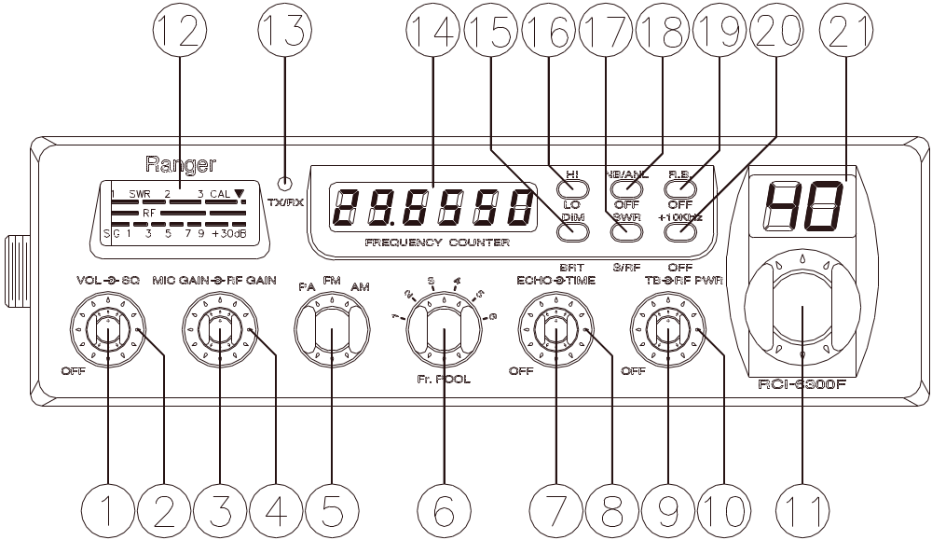

Figure 2-1 Front Panel

2.0 INTRODUCTION
This section explains the basic operating procedures for the RANGER RCI-6300F HP / RCI-6300F TB mobile transceiver.

2.1 CONTROL AND CONNECTIONS

2.1.1 FRONT PANEL
Refer to the above Figure 2-1 for the location of the following controls.

1. ON/OFF VOLUME CONTROL
This knob controls the volume and the power to the radio. To turn the radio on, rotate the knob clockwise. Turning the knob further will increase the volume of the receiver.

2. SQUELCH CONTROL
This switch is used to eliminate background noise being heard through the receiver which can be disturbing when no transmissions are being received. To use this feature, turn the switch fully counterclockwise and then turn clockwise slowly until the background noise is just eliminated. Further clockwise rotation will increase the threshold level which a signal must overcome in order to be heard. Only strong signals will be heard at a maximum clockwise setting.

3. MIC GAIN CONTROL
Adjusts the microphone gain in the transmit and PA modes. This controls the gain to the extent that full talk power is available several inches away from the microphone. In the Public Address (PA) mode, the control functions as the volume control.

4. RF GAIN CONTROL
This control is used to reduce the gain of the RF amplifier under strong signal conditions.

5. MODE SWITCH
This control allows you to select one of the following operating modes: PA/FM/AM.

In the PA position, the radio acts as a public address amplifier. Your voice will come out of the speaker that is plugged into the PA. SP. jack on the rear panel. The radio does not operate when you are in the PA mode. In the FM/AM position, the PA function is disabled and the unit will transmit and receive on the speaker that is connected to the radio.

6. FR. POOL SELECTOR
This switch is used to select the frequency range of operation (1 - 6).

7. ECHO SWITCH
This control is used for echo effect.

8. TIME CONTROL
This time control is used to control the intervals of the echo sound.

9. TALKBACK CONTROL
Adjust this knob for desired volume of Talkback. This is used to monitor your own voice. For example, you could use this feature to compare different microphones.

10. RF POWER CONTROL
This control allows the user to adjust RF power output.

11. CHANNEL SELECTOR
This control is used to select a desired transmit and receive channel.

12. FRONT PANEL METER
The Front Panel Meter allows the user to monitor signal strength, RF output power and SWR level.

13. TX/RX LED
The red LED indicates the unit is in the transmit mode. The green LED indicates the unit is in the receive mode.

14. FREQUENCY COUNTER
This display indicates the frequency of operation.

15. DIM/BRT SWITCH
This switch controls the level of brightness for the meter lamp, frequency display and the channel display. Press this switch (DIM) for the meter lamp, frequency display and the channel display to be dimly lighted. Depress this switch (BRT) for brighter effects.

16. HI/LO SWITCH
This switch selects received audio tone quality. In LO position, bass is increased and in HI position, treble is increased.

17. S-RF/SWR SWITCH
This is a two-function switch. In the S-RF position, the meter will indicate the strength of the signal being received, as well as the relative RF output of transmission. To use the meter to measure the standing wave ratio, turn the switch to the SWR position. The SWR function is self-calibrating.

18. NB/ANL/OFF SWITCH
In the NB/ANL position, the RF Noise Blanker and the Automatic Noise Limiter in the audio circuits are also activated. The Noise Blanker is very effective in eliminating repetitive impulse noise such as ignition interference.

19. R.B./OFF SWITCH
In the Roger Beep position, the radio transmits an audio tone at the end of your transmission to indicate that transmission has ended. As a courtesy to others, use the Roger Beep only when necessary.

20. +10KHz/OFF SWITCH
When the switch is pressed the frequency is shifted 10KHz up.

21. CHANNEL DISPLAY
The channel display indicates the current selected channel.

2.1.2 REAR PANEL
Figure 2-2 represents the location of the following connections:

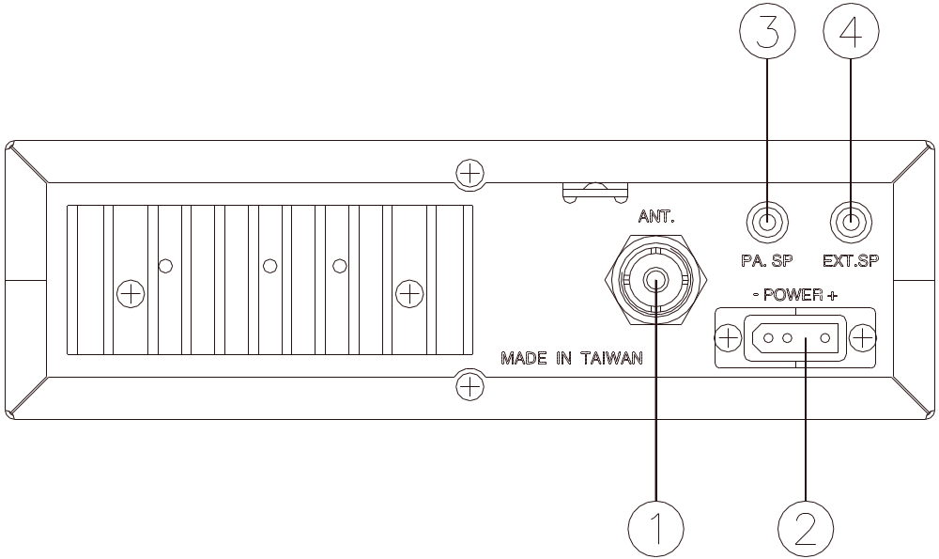

Figure 2-2 Rear Panel

1. ANTENNA
This jack accepts 50 ohms coaxial cable with a PL- 259 type plug.

2. POWER
This connector accepts 13.8V DC power cable with built-in fuse. The power cord provided with the radio has a black and red wire. The black goes to negative and the red goes to positive.

3. PA. SP.
This jack is for PA operation. Before operating, you must first connect a PA speaker (8 ohms, 4W) to this jack.

4. EXT. SP.
This jack accepts 4 to 8 ohms, 4 watts external speaker. When the external speaker is connected to this jack, the built-in speaker will be disabled.

2.1.3 FREQUENCY CHART

 | FR. POOL
CHANNEL | 1 (MHz) | 2 (MHz) | 3 (MHz) | 4 (MHz) | 5 (MHz) | 6 (MHz)
1 | 28.245 | 28.695 | 29.145 | 28.315 | 28.765 | 29.215
2 | 28.255 | 28.705 | 29.155 | 28.325 | 28.775 | 29.225
3 | 28.265 | 28.715 | 29.165 | 28.335 | 28.785 | 29.235
4 | 28.285 | 28.735 | 29.185 | 28.355 | 28.805 | 29.255
5 | 28.295 | 28.745 | 29.195 | 28.365 | 28.815 | 29.265
6 | 28.305 | 28.755 | 29.205 | 28.375 | 28.825 | 29.275
7 | 28.315 | 28.765 | 29.215 | 28.385 | 28.835 | 29.285
8 | 28.335 | 28.785 | 29.235 | 28.405 | 28.855 | 29.305
9 | 28.345 | 28.795 | 29.245 | 28.415 | 28.865 | 29.315
10 | 28.355 | 28.805 | 29.255 | 28.425 | 28.875 | 29.325
11 | 28.365 | 28.815 | 29.265 | 28.435 | 28.885 | 29.335
12 | 28.385 | 28.835 | 29.285 | 28.455 | 28.905 | 29.355
13 | 28.395 | 28.845 | 29.295 | 28.465 | 28.915 | 29.365
14 | 28.405 | 28.855 | 29.305 | 28.475 | 28.925 | 29.375
15 | 28.415 | 28.865 | 29.315 | 28.485 | 28.935 | 29.385
16 | 28.435 | 28.885 | 29.335 | 28.505 | 28.955 | 29.405
17 | 28.445 | 28.895 | 29.345 | 28.515 | 28.965 | 29.415
18 | 28.455 | 28.905 | 29.355 | 28.525 | 28.975 | 29.425
19 | 28.465 | 28.915 | 29.365 | 28.535 | 28.985 | 29.435
20 | 28.485 | 28.935 | 29.385 | 28.555 | 29.005 | 29.445
21 | 28.495 | 28.945 | 29.395 | 28.565 | 29.015 | 29.465
22 | 28.505 | 28.955 | 29.405 | 28.575 | 29.025 | 29.475
23 | 28.535 | 28.985 | 29.435 | 28.605 | 29.005 | 29.505
24 | 28.515 | 28.965 | 29.415 | 28.585 | 29.035 | 29.485
25 | 28.525 | 28.975 | 29.425 | 28.595 | 29.045 | 29.495
26 | 28.545 | 28.995 | 29.445 | 28.615 | 29.065 | 29.495
27 | 28.555 | 29.005 | 29.455 | 28.625 | 29.075 | 29.515
28 | 28.565 | 29.015 | 29.465 | 28.635 | 29.085 | 29.525
29 | 28.575 | 29.025 | 29.475 | 28.645 | 29.095 | 29.535
30 | 28.585 | 29.035 | 29.485 | 28.655 | 29.105 | 29.545
31 | 28.595 | 29.045 | 29.495 | 28.665 | 29.115 | 29.555
32 | 28.605 | 29.055 | 29.505 | 28.675 | 29.125 | 29.565
33 | 28.615 | 29.065 | 29.515 | 28.685 | 29.135 | 29.575
34 | 28.625 | 29.075 | 29.525 | 28.695 | 29.145 | 29.585
35 | 28.635 | 29.085 | 29.535 | 28.705 | 29.155 | 29.595
36 | 28.645 | 29.095 | 29.545 | 28.715 | 29.165 | 29.605
37 | 28.655 | 29.105 | 29.555 | 28.725 | 29.175 | 29.625
38 | 28.665 | 29.115 | 29.565 | 28.735 | 29.185 | 29.635
39 | 28.675 | 29.125 | 29.575 | 28.745 | 29.195 | 29.645
40 | 28.685 | 29.135 | 29.585 | 28.755 | 29.205 | 29.655

2.2 MICROPHONE

The receiver and transmitter are controlled by the push-to-talk switch on the microphone. Press the switch and the transmitter is activated, release switch to receive. When transmitting, hold the microphone two inches from the mouth and speak clearly in a normal voice. The radio comes complete with low impedance (500 ohm) dynamic microphone.

2.3 OPERATION

2.3.1 PROCEDURE TO RECEIVE
1. Be sure that power source, microphone and antenna are connected to the proper connectors before going to the next step.

2. Turn unit on by turning VOL knob clockwise on transceiver.

3. Set the VOL to a comfortable listening level.

4. Set the MODE switch to the desired mode.

5. Listen to the background noise from the speaker. Turn the SQ knob slowly clockwise until the noise just disappears. The SQ is now properly adjusted. The receiver will remain quiet until a signal is actually received. Do not advance the control too far or some of weaker signals will not be heard.

6. Set the CHANNEL selector switch to the desired channel.

7. Set the RF GAIN control fully clockwise for maximum RF gain.

2.3.2 PROCEDURE TO TRANSMIT
1. Select the desired channel of transmission

2. Set the MIC GAIN control fully clockwise.

3. If the channel is clear, press the push-to-talk switch on the microphone and speak in a normal voice.

2.4 ALTERNATE MICROPHONES AND INSTALLATION

For best results, the user should select a low impedance dynamic type microphone or a transistorized microphone. Transistorized type microphones have a low output impedance characteristic. The microphones must be provided with a four-lead cable. The audio conductor and its shielded lead comprise two of the leads. The third lead is for transmit control and the fourth is for receiving control. The microphone should provide the functions shown in schematic below (Figure 2-3).

4 WIRE MIC CABLE

 | Pin Number | Mic Cable Lead
 | 1 | Audio Shield
 | 2 | Audio Lead
 | 3 | Transmit Control
 | 4 | Receive Control

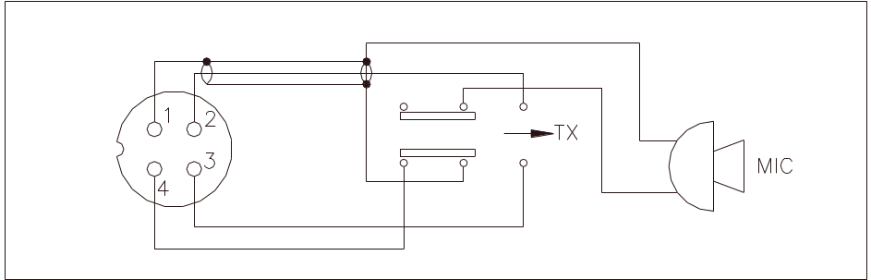

Figure 2-3 Your Transceiver Microphone Schematic

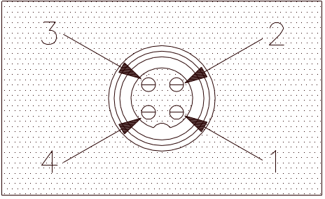

Figure 2-4 Microphone plug pin numbers viewed from rear of pin receptacle.

RCI-6300F HP  RCI-6300F TB |  | CHAPTER 3  CIRCUIT DESCRIPTION

3.0 INTRODUCTION
This section explains the technical theory of operation for the RCI-6300F HP / RCI-6300F TB mobile transceiver.

3.1 PLL CIRCUIT
The Phase Lock Loop (PLL) circuit is responsible for developing the receiver’s first local oscillator signal and the transmitter’s exciter signal. The PLL circuit consists primarily of IC2, IC3, IC4, IC5 Q25, Q27, Q28, Q29 and Q61. The PLL circuit is programmed by the rotary channel switch GPS-0501. The switch communicates the correct binary data information to the programmable divider inside of IC3. IC3 then controls the VCO (Voltage Controlled Oscillator), consisting of VCO to oscillate on the correct frequency. This signal is fed either into the receiver’s first mixer (for receive operation) or the transmitter’s mixer (for transmit operation).

3.2 RECEIVER CIRCUIT
The incoming RF signal comes into the radio via the antenna and into the front-end pre-amp, Q17. The RF signal is fed into the mixer circuit Q18 & Q19 and then into the IF section of the receiver (depending on the mode of operation). The signals is then detected by either the AM detector or FM detector and then fed to the audio amplifier section of the receiver and finally out to the speaker.

3.3 TRANSMITTER MODULATION CIRCUIT
(i) The transmitter modulation circuit modulates the low-level RF signal from the PLL exciter circuit with the user’s audio voice signal from the microphone. The audio from the microphone is then amplified and fed into the transmit amplifier circuit.

(ii) If the transceiver is in the AM mode, the AF power amplifier modulates the last RF amplifier which produces a true amplitude modulated RF signal.

3.4 TRANSMITTER AMPLIFIER CIRCUIT
The transmitter takes the basic exciter signal from the TX mixer and amplifies it through a series of amplifiers consisting of Q50, Q51, Q49, Q47, Q48 and EPA010010A (only for RCI-6300F TB) where it is sent out to the antenna connector.

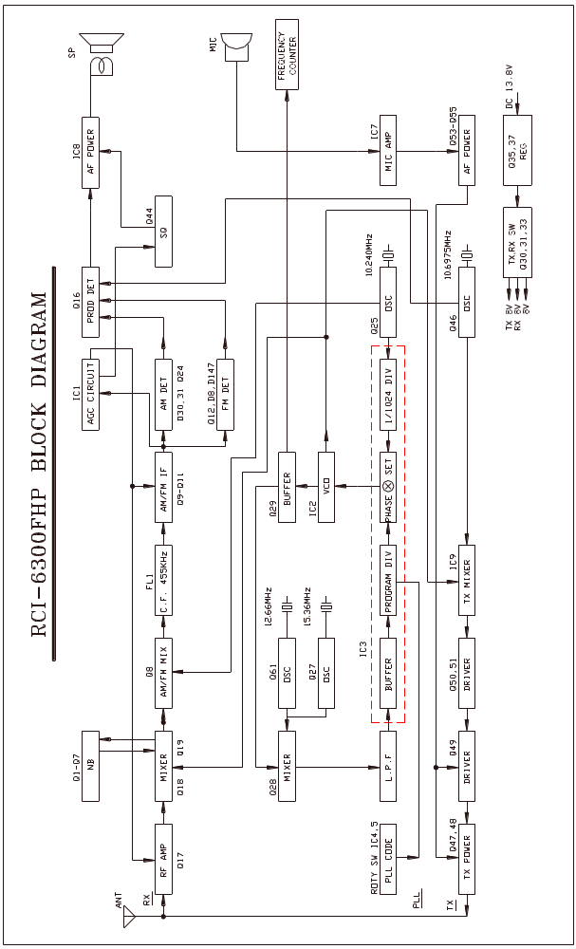
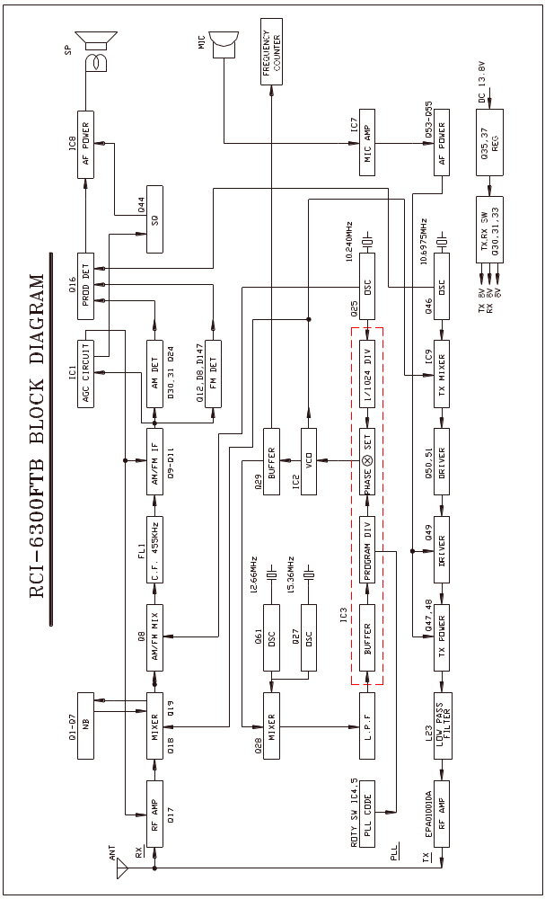
RCI-6300F HP / RCI-6300F TB FREQUENCY COUNTER CIRCUIT DIAGRAM
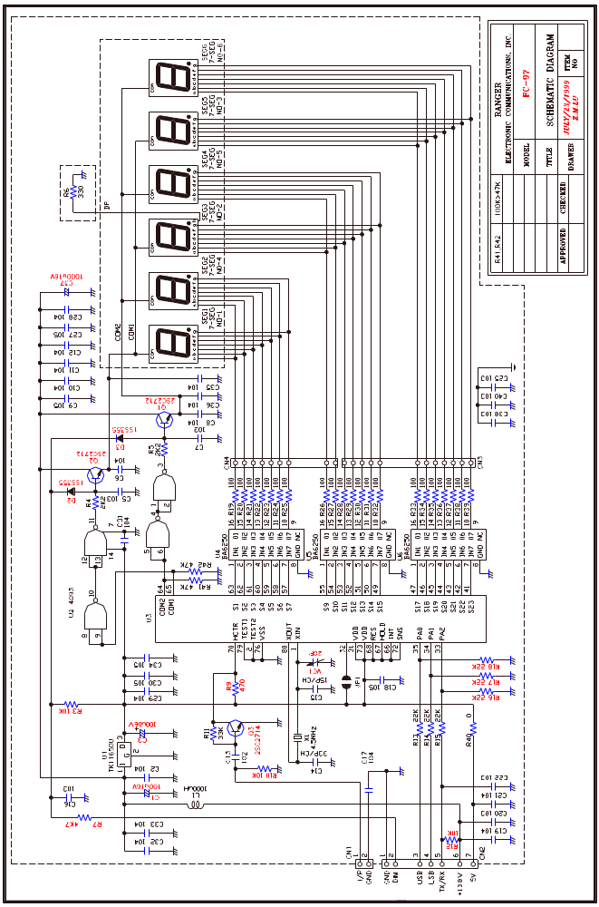
RCI-6300F HP / RCI-6300F TB ECHO BOARD (EB-99) CIRCUIT DIAGRAM

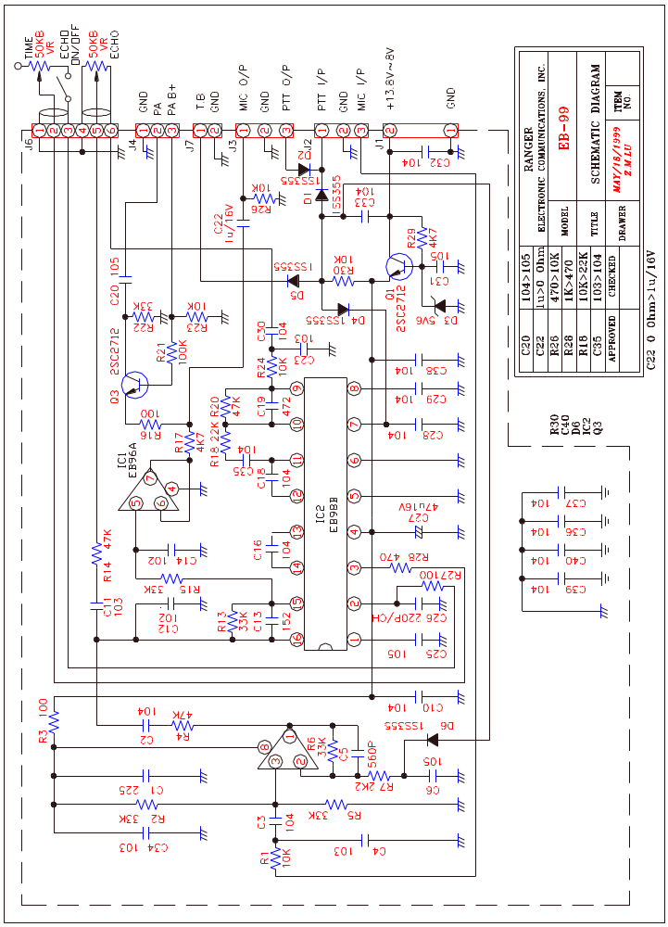
RCI-6300F HP  RCI-6300F TB |  | CHAPTER 4  ALIGNMENT

4.0 REQUIRED TEST EQUIPMENT

① DC Power Supply (13.8VDC, 20A)  ② RF Wattmeter (25~60 MHz, 100W)  ③ Multimeter (Digital)  ④ Automatic Modulation Meter  ⑤ Audio Signal Generator | ⑥ Frequency Counter (100 MHz)  ⑦ RF Signal Generator (100 MHz)  ⑧ Automatic Distortion Meter  ⑨ Oscilloscope (50 MHz)  ⑩ Sinad Meter

4.1 ALIGNMENT PROCEDURES
This transceiver has been aligned at the factory and does not require any adjustments at installation. The required test equipment listed are used for the test setup or alignment shown in Figure 4-1 Transmitter Test Setup and Figure 4-2 Receiver Test Setup. These test setup are used in part or total during the following adjustments and refer to Figure 4-3 for adjustment location.

4.1.1 PLL ALIGNMENT

ITEM | U.U.T. SETTING | ADJUST POINT | MEASUREMENT
VCO Voltage | Disconnect the “short PCB” from TP7, TP8 and TP9.  Set radio to Fr Pool 6, CH 40 AM RX mode.  Set the +10KHz switch to OFF position.  Connect Multimeter to TP2.  Connect Oscilloscope to TP3. | L14  L15 | 6.5 VDC ± 0.1  Maximum Output and Balance. (CH 1 & CH 40)
AM Frequency | Set radio to Fr Pool 1, CH 1 AM RX mode.  Set radio to Pool 6, CH 40 AM RX mode.  Connect Frequency Counter to TP3. | L20  L17 | 17.5500 MHz + 20Hz  18.9600 MHz + 20Hz
TX Frequency | Set radio to Fr Pool 1, CH 1 AM TX mode.  Connect Frequency Counter to TP3. | VR7 | 17.5500 MHz + 20Hz
AM OSC | Set radio to Fr Pool 1, CH 1 AM TX mode.  Connect Frequency Counter to TP5. | L23 | 10.6950 MHz + 20Hz

4.1.2 TRANSMITTER ALIGNMENT

ITEM | U.U.T. SETTING | ADJUST POINT | MEASUREMENT
TX Power | Set radio to Fr Pool 2, CH 19 AM TX mode.  Connect “short PCB” to TP7, TP8 and TP9.  Connect RF Power Meter to antenna jack.  Set RF Power Fully Clockwise. | L40,L42,L43,L44  L40,L42 | Power MAX.  Spurious emission Min.  Balance Power between CH 1 and CH 40.
AM TX Power | Set radio to Fr Pool 2, CH 19 AM TX mode.  Modulation off. | VR14 | 10W (RCI-6300F HP)  50W (RCI-6300F TB)
RF Power Meter | Set radio to Fr Pool 2, CH 19 AM TX mode.  Set SWR/S-RF switch to S/RF position.  Modulation off. | VR9 | Adjust RF Power meter needle until it is in-between the green and red bar on PWR scale.
AM  Modulation | Set radio to Fr Pool 2, CH 19 AM TX mode.  Set Mic Gain Fully Clockwise.  AF signal 30 mV, 1 KHz to microphone. | VR16 | 90%
FM Deviation | Set radio to Fr Pool 2, CH 19 FM TX mode.  Set Mic Gain Fully Clockwise.  AF signal 30 mV, 1 KHz to microphone. | VR5 | 4KHz
Frequency Counter Adjust | Set radio to Fr Pool 2, CH 19 AM RX mode.  Set DIM/BRT switch to BRT position. | VC1 on frequency counter | Display should be 28.9150

4.1.3 RECEIVER ALIGNMENT

ITEM | U.U.T. SETTING | ADJUST POINT | MEASUREMENT
AM Sensitivity | Set radio to Fr Pool 2, CH 19 AM RX mode.  Set RF Gain Fully Clockwise.  Set SQ Fully Counter Clockwise.  Set VOL Control at 2 o’clock.  Set NB-ANL/OFF switch to OFF position.  Connect RF SG to antenna jack  Frequency 28.915 MHz, 1uV. Mod 30%.  Set radio to Pool 6, CH 40 AM mode.  RF SG setting 29.655 MHz.  Set radio to Pool 1, CH 1 AM mode.  RF SG setting 28.245 MHz. | L2,3,5,6,7,8,  9,10  L5,L6  L5,L6 | Audio output > 2V  S/N > 10 dB.  For Balance between CH 1 and CH 40.
FM Sensitivity | Set radio to Fr Pool 2, CH 19 FM RX mode.  Set MODE switch to FM mode.  RF SG setting 28.915 MHz, 0.5uV. Mod 3KHz. | L4 | Audio output Max  S/N > 20 dB.
NB Adjust | Set radio to Fr Pool 2, CH 19 AM RX mode  RF SG setting 28.915 MHz, 100uV. Mod off.  Set NB-ANL/OFF switch to NB/ANL position.  Connect Voltmeter to TP1. | L1 | DC voltage to max.  ( >2.0V )
AM Squelch | Set radio to Fr Pool 2, CH 19 AM RX mode.  Set SQ control fully clockwise.  RF SG setting 28.915 MHz, 1 mV. Mod 30%. | VR4 Slowly | Adjust very slowly until squelch just open
AM S/RF Meter | Set radio to Fr Pool 2, CH 19 AM RX mode.  Set SWR/S-RF switch to S/RF position.  RF SG setting 28.915 MHz, 100uV. Mod 30%. | VR1 | Meter needle to S9 on the S scale

Figure 4-1 Transmitter test setup

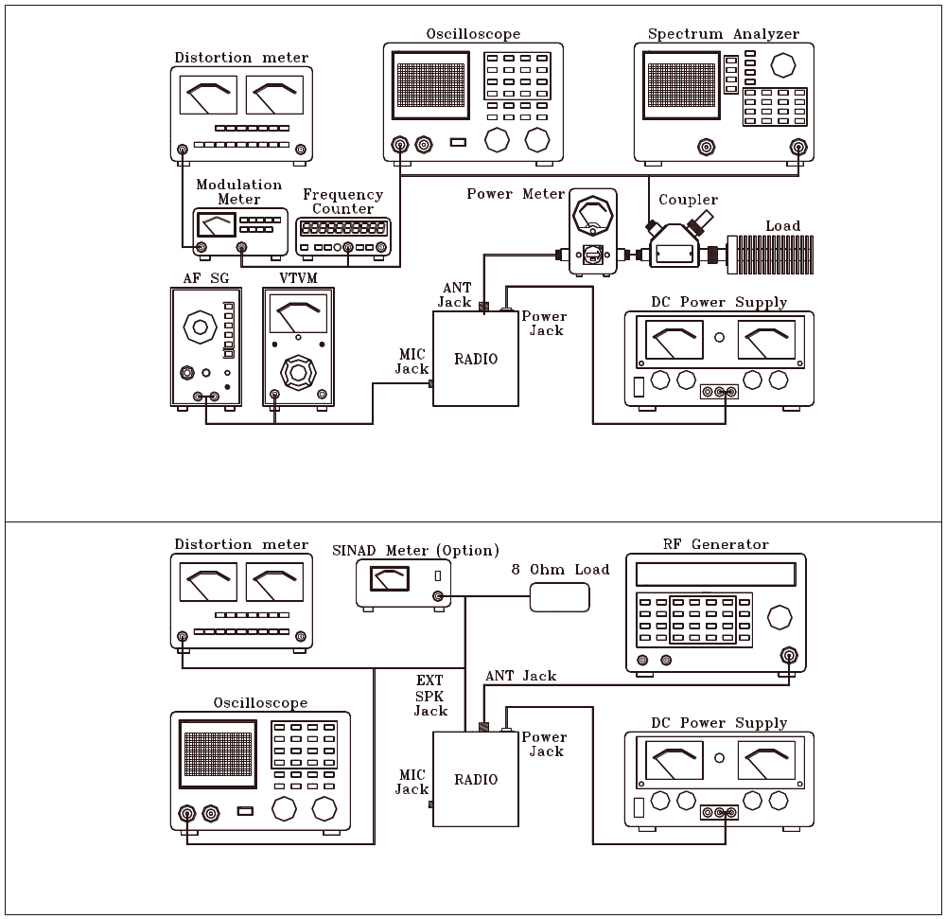

Figure 4-2 Receiver test setup

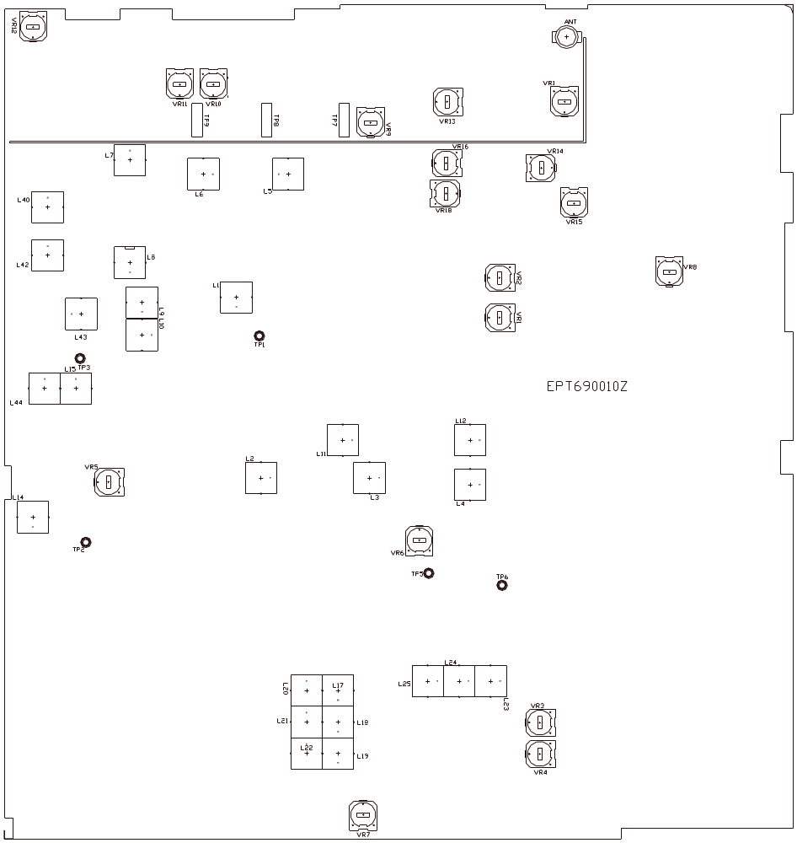

Figure 4-3 Main PCB Adjustment Location

RCI-6300F HP  RCI-6300F TB |  | CHAPTER 5  MAINTENANCE

5.0 PRECAUTIONS
The inherent quality of the solid-state components used in this transceiver will provide many years of continuous use. Taking the following precautions will prevent damage to the transceiver.

(i) Never key the transmitter unless an antenna or suitable dummy load is connected to the antenna receptacle.

(ii) Ensure that the input voltage does not exceed 16 VDC or fall below 11 VDC.

(iii) During alignment, do not transmit for more than 10 seconds at a time. Transmitting over long periods can cause heat built-up and cause transmitter damage.

5.1 PERIODIC INSPECTION
This unit is aligned at the factory to deliver maximum performance. However, continued performance cannot be expected without periodic inspection and maintenance. Important points to be checked regularly are as follows;

Check Item | Action
Whip antenna (option) | If cracked or broken, replace it.
Coaxial cable | If sheath is cracked, seal with vinyl tape. If immersed with water, install new coaxial cable.
Coaxial & power plug connections | If loosened, reconnect. If corroded, clean contacts.
Battery connection | If corroded, clean power terminals.
Ground terminal | If corroded, clean terminal.

5.2 FUSE REPLACEMENT
To protect the equipment from serious damage, a fuse is provided on the power supply lines. The fuse protect against overvoltage / reverse polarity and internal fault of the equipment. If the fuse has blown, first find out the cause of the trouble before replacing it. A fuse rated for more than the transceiver requirement should not be used, since it may permanently damage the equipment. Damage due to overfusing is not covered by the warranty.

RCI-6300F HP  RCI-6300F TB |  | CHAPTER 6  DIAGRAMS & PARTS LIST

6.0 GENERAL
Information on most electrical and mechanical parts is included in the parts list. The reference designators are in alphanumeric order.

6.1 ORDERING REPLACEMENT PARTS
Parts orders should be referred to the Parts Department at:

• Ranger Communications, Inc.
3377 Carmel Mountain Road
San Diego, CA 92121

Tel: 858-259-0287
Fax: 858-259-0437

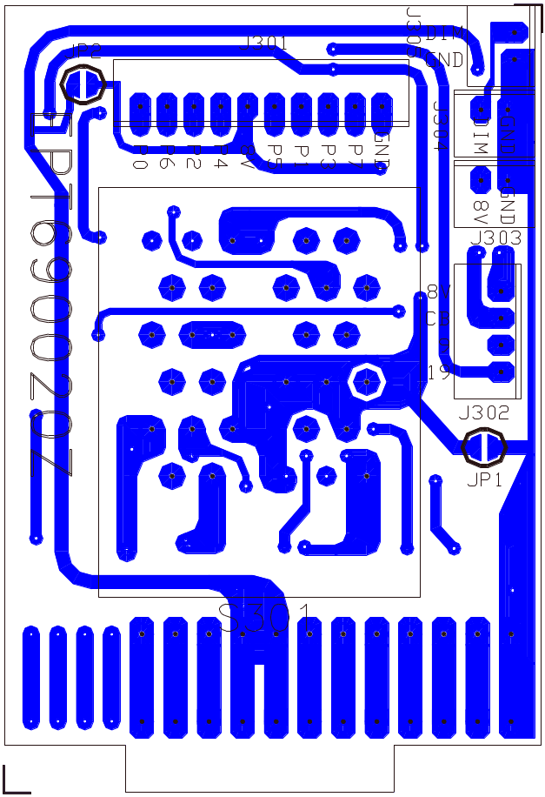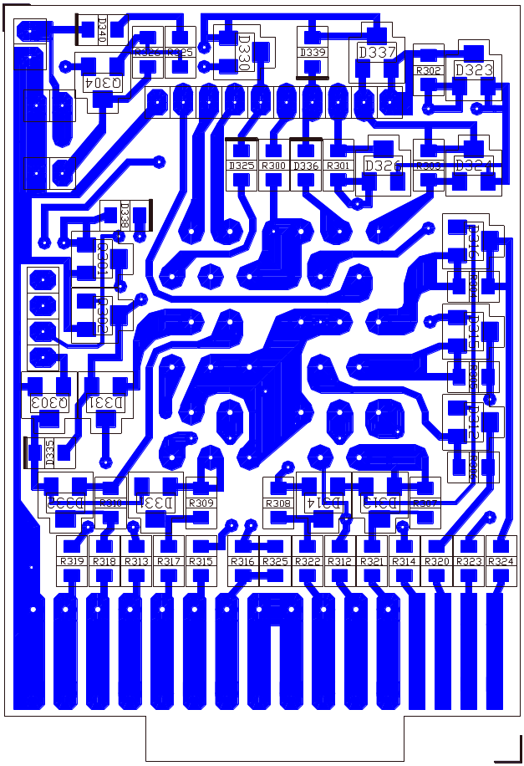

PART LIST:

RCI-6300F HP / RCI-6300F TB ROTARY SW P.C.B

ITEM | REFERENCE NUMBER | RANGER PART NUMBER | DESCRIPTION
1 |  | EPT690020Z | ROTARY SW P.C.B
2 | R300-R310,D325,  D331,D336 | RCY010004Z | 0 OHM 0.1W
3 | R312-R325 | RCY011024Z | 1K OHM 0.1W
4 | R327 | RCY012224Z | 2.2K OHM 0.1W
5 | R326 | RCY014724Z | 4.7K OHM 0.1W
6 | D340 | EDSS00355Y | DIODE 1SS355
7 | Q304 | TY2SC2712G | TR 2SC2712GR
8 | J303-J305 | EX07N48223 | PCB CONN/S 2PIN
9 | J301 | EX07N48209 | PCB CONN/S 10PIN
10 | S301 | EWRT32000S | ROTARY SW

REMARK:
LEFT: COMPONENT SIDE (BLUE)
RIGHT: COPPER SIDE (BLUE)

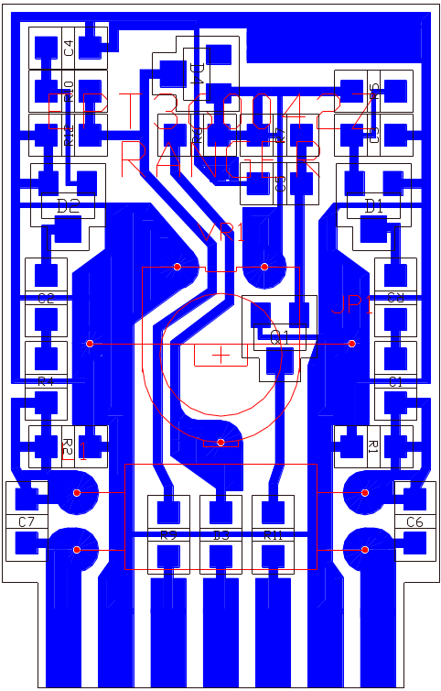

PART LIST:

RCI-6300F HP ANT P.C.B

ITEM | REFERENCE NUMBER | RANGER PART NUMBER | DESCRIPTION
1 |  | EPT360042Z | ANT P.C.B
2 | R9 | RCY010004Z | 0 OHM 0.1W
3 | R1 | RCY014714Z | 470 OHM 0.1W
4 | R3,R4 | RCY011014Z | 100 OHM 0.1W
5 | R2 | RCY013314Z | 330 OHM 0.1W
6 | R5,R11 | RCY011024Z | 1K OHM 0.1W
7 | R10 | RCY012224Z | 2.2K OHM 0.1W
8 | R12 | RCY014724Z | 4.7K OHM 0.1W
9 | R7 | RCY011034Z | 10K OHM 0.1W
10 | C5 | RCY012234Z | 22K OHM 0.1W
11 | C7 | CK1059AB1A | 0.5PF 50WV
12 | C6 | CK1030AB1A | 3PF 50WV
13 | C3,C4 | CK2104AB7R | 0.1uF 25WV
14 | C1,C2 | CK1103AB7L | 0.001uF 50WV
15 | Q1 | TY2SC2712G | TR 2SC2712GR
16 | D3 | EDSS00355Y | DIODE 1SS355
17 | D1,D2 | EDHM0198SY | DIODE HSM198S
18 | D4 | EDMA0028TY | DIODE MA28T
19 | L1 | ECRFZ10053 | RF COIL C3RH0610
20 | VR1 | RE10300009 | S/F/R 10K OHM
21 | JP1 | WX01070715 | JUMPER WIRE

REMARK:
COPPER SIDE (BLUE)
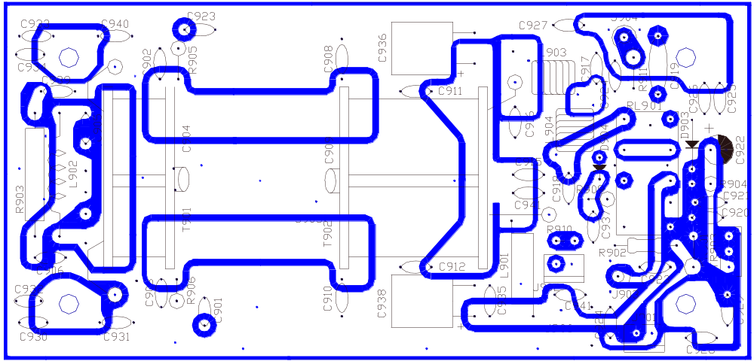

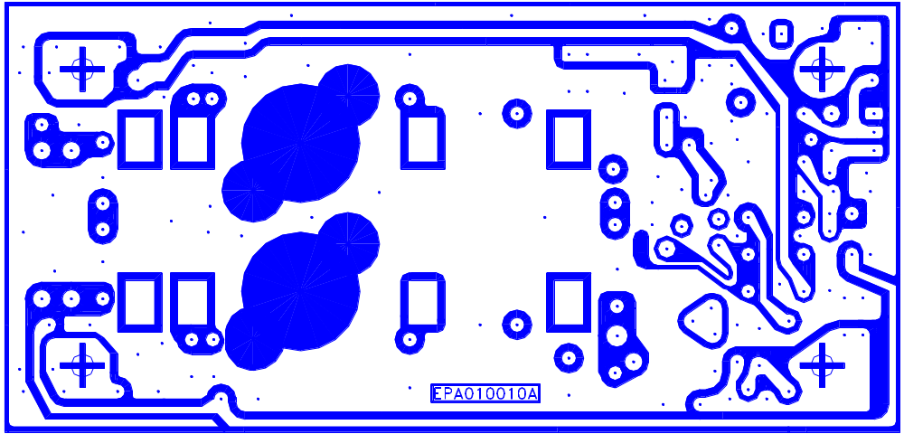

PART LIST:

RCI-6300F TB POWER P.C.B

ITEM | REFERENCE NUMBER | RANGER PART NUMBER | DESCRIPTION
1 |  | EPA010010A | POWER P.C.B
2 | R904 | RCU141094Z | 1 OHM 1/4W
3 | R905,R906 | RCU141004Z | 10 OHM 1/4W
4 | R909 | RCP141034Z | 10K OHM 1/4W
5 | R902 | RCM141024A | 1K OHM 1/4W
6 | R911 | RCP121034Z | 10K OHM 1/2W
7 | R903 | RCP202204Z | 22 OHM 2W
8 | R901,R909(R910) | RE10200046 | S/F/R 1K OHM
9 | BETWEEN C901 & GROUND | RCP141024Z | 1K OHM 1/4W
10 | T901,T902 | RFP202214Z | 220 OHM 2W
ITEM | REFERENCE NUMBER | RANGER PART NUMBER | DESCRIPTION
11 | COPPER SIDE | RCY011014Z | 100 OHM 0.1W
12 | C901 | CC0501015A | 100PF 50WV
13 | C943 | CC0500591A | 0.5PF 50WV
14 | C906,C926,C932,  C937,TERMINALx2 | CC0501037L | 0.01uF 50WV
15 | C905,C920,C921,C923x2,C924x2,C925,C935,C939,C941,T901-902x2,  C927-C931,C933,C940 | CC0501047L | 0.1uF 50WV
16 | C918 | CD3006804Z | 68PF 300WV
17 | C916 | CD3001514Z | 150PF 300WV
18 | C917 | CD5001018Z | 100PF 500WV
19 | C908,C910,C936 | CD3001814Z | 180PF 300WV
20 | C945 | CD5005614Z | 560PF 500WV
21 | C909 | CD5008214Z | 820PF 500WV
22 | C904 | CD1001024Z | 0.001uF 100WV
23 | C919 | CX0071037Z | HV DISC/ C 0.01μF
24 | C922 | CE0162277Z | 220uF 16WV
25 | C938 | CE0352277Z | 220uF 35WV
26 | TR903 | T2SD02531Z | TR 2SD2531
27 | TR901,TR902 | T2SC02290Z | TR 2SC2290
28 | D903,D904 | ED1N04148Z | DIODE 1N4148
29 | D901,D902 | ED1N04001Z | DIODE 1N4001
30 | L903,L904 | ECSPG18069 | SPRING COIL
31 | L901 | ECBAD18553 | BEAD COIL
32 | L902 | ECCHK16098 | CHOKE COIL
33 | T901 | ECRFZ10096 | RF COIL
34 | T902 | ECRFZ10097 | RF COIL
35 | J901,J902 | EX07N41226 | PCB CONN/S 2PIN
36 | RL901 | EX05N40825 | RELAY
37 | J903,J904 | GZZZ50062Z | V TYPE JACK
38 | J905,J906 | GZZZ50011Z | C PIN

REMARK:
TOP: COMPONENT SIDE (WHITE)
BOTTOM: COPPER SIDE (WHITE)

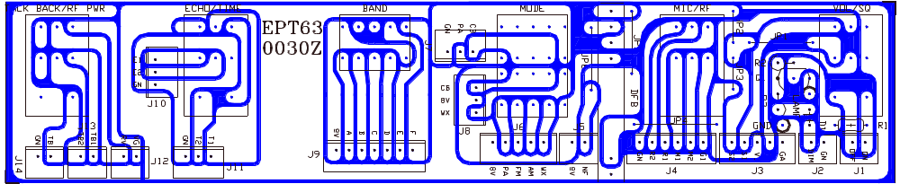

PART LIST:

RCI-6300F HP / RCI-6300F TB BAND SWITCH P.C.B

ITEM | REFERENCE NUMBER | RANGER PART NUMBER | DESCRIPTION
1 |  | EPT630030Z | BAND SWITCH P.C.B
2 | R1 | RCP164704Z | 47 OHM 1/16W
3 | R2,R3 | RCP161024Z | 1K OHM 1/16W
4 | D1 | ED1N04148Z | DIODE 1N4148
5 | Q1 | T2SC00945P | TR 2SC945P
6 | J1,J2,J12-J14 | EX07N48223 | PCB CONN/S 2PIN
7 | J7,J10 | EX07N48350 | PCB CONN/S 3PIN
8 | J6 | EX07N48490 | PCB CONN/S 4PIN
9 | J9 | EX07N48224 | PCB CONN/S 7PIN
10 | J11 | EX07W48824 | PCB CONN/S 3PIN
11 | J3 | EX07W48826 | PCB CONN/S 5PIN
12 | J4 | EX07W48827 | PCB CONN/S 6PIN
13 | JP3 | WX01070705 | JUMPER WIRE
14 | JP1 | WX01070710 | JUMPER WIRE
15 | MIC/RF | RV10203524 | VR 1KB/1KA
16 | TALK BACK/RF PWR | RV20303560 | VR 20KB/5KB
17 | VOL/SQ,ECHO/TIME | RV50303522 | VR 50KB/50KA W/SW
18 | MODE | EWRT32084S | ROTARY SW 3N
19 | BAND | EWRT32094S | ROTARY SW 6N

REMARK:
COPPER SIDE (WHITE)

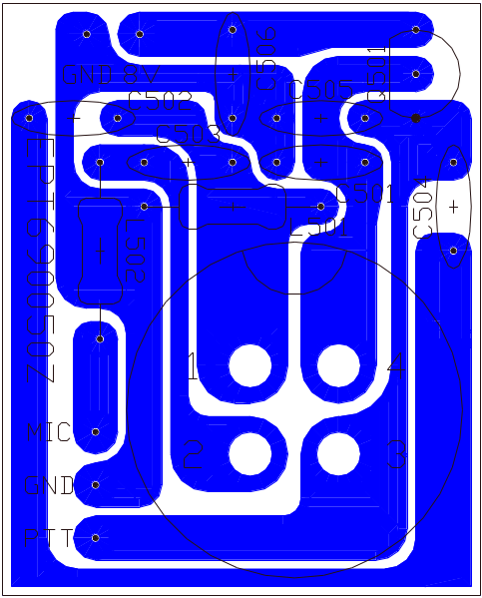

PART LIST:

RCI-6300F HP / RCI-6300F TB MIC P.C.B

ITEM | REFERENCE NUMBER | RANGER PART NUMBER | DESCRIPTION | REMARK
1 |  | EPT690050Z | MIC P.C.B
2 | C502-C504 | CC0501027L | 0.001uF 50WV
3 | C501 | CC0501027L | 0.001uF 50WV | RCI-6300F HP
4 | C505,C506 | CC0501037L | 0.01uF 50WV
5 | L501 | ECCHK16001 | CHOKE COIL 5.6uH
6 | L502 | ECBAD18526 | BEAD COIL
7 | 1-4 | EX06N41020 | MIC JACK
8 | MIC/GND/PTT | EX07N48903 | WIRE CONN/H 3PIN

REMARK:
COPPER SIDE (BLUE)

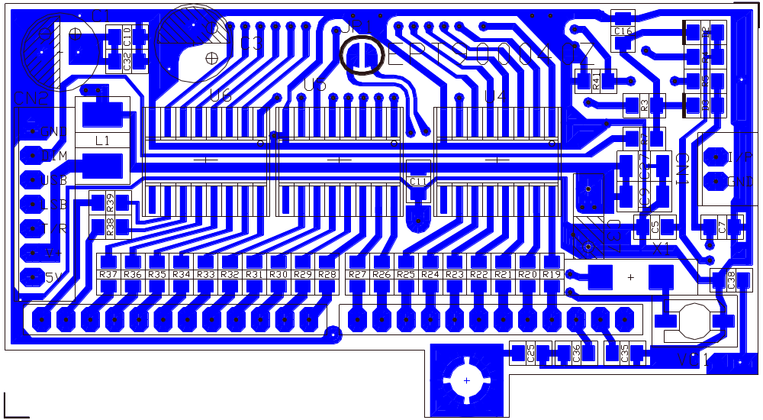

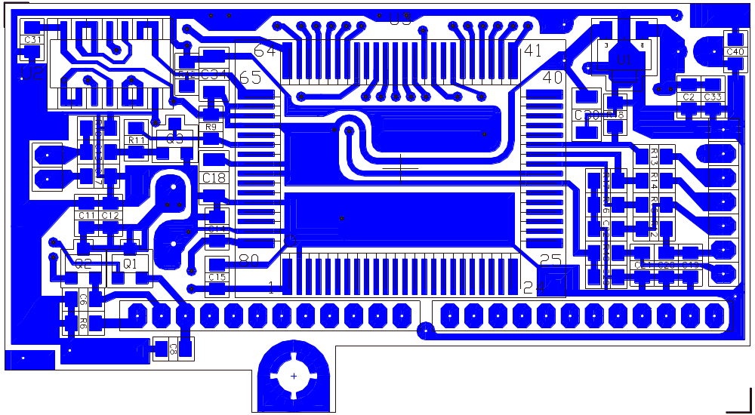

PART LIST:

RCI-6300F HP / RCI-6300F TB COUNTER P.C.B

ITEM | REFERENCE NUMBER | RANGER PART NUMBER | DESCRIPTION
1 |  | EPT900040Z | COUNTER P.C.B
2 | R40 | RCY010004Z | 0 OHM 0.1W
3 | R19-R39 | RCY011014Z | 100 OHM 0.1W
4 | R6 | RCY013314Z | 330 OHM 0.1W
5 | R9 | RCY014714Z | 470 OHM 0.1W
6 | R4,R5 | RCY012224Z | 2.2K OHM 0.1W
7 | R7 | RCY014724Z | 4.7K OHM 0.1W
8 | R3,R10,R12 | RCY011034Z | 10K OHM 0.1W
9 | R13-R18 | RCY012234Z | 22K OHM 0.1W
10 | R11 | RCY013334Z | 33K OHM 0.1W
11 | R41,R42 | RCY014734Z | 47K OHM 0.1W
12 | C15 | CK1150AB4A | 15PF 50WV
13 | C14 | CK1330AB4A | 33PF 50WV
14 | C2,C6,C8,C10,C11,C12,  C17,C19,C21,C29,C31,  C32,C33,C35,C36,C28 | CK2104AB7R | 0.1uF 25WV
15 | C5,C7,C16,C20,C22,  C25,C38,C40 | CK1103AB6U | 0.01uF 50WV
16 | C13 | CK1102AB7L | 0.001uF 50WV
17 | C9,C18,C27,C30,C34 | CK5105AA7R | 1uF 16WV
18 | U3 | YNRG0GX3SP | IC LC7232N 18PIN
19 | U2 | YNTA04073B | IC TC4093BFN 14PIN
20 | U4,U5,U6 | YNR006250F | IC BA6250F 16PIN
21 | U1 | YNT011650U | IC TK11650U 3PIN
22 | Q3 | TY25C2714Z | TR 2SC2714
23 | Q1,Q2 | TY2SC2712G | TR 2SC2712GR
24 | D2,D3 | EDSS00355Y | DIODE 1SS355
25 | L1 | YCCHK16259 | CHOKE COIL 1000UH
26 | VC1 | CV038200AY | TRIMMER/C 20PF
27 | C1,C3 | CEM161077A | 100UF 16WV
28 | X1 | EYCAP04500 | CRYSTAL 4.500MHz
29 | C37 | CE0161087Z | 1000UF 16WV
30 | COUNTER PCB x2 | EX07N48927 | PCB CONN/S 12PIN
31 | CN1 | EX07N48223 | PCB CONN/S 2PIN
32 | CN2 | EX07N48224 | PCB CONN/S 7PIN

REMARK:
TOP: COMPONENT SIDE (BLUE)
BOTTOM: COPPER SIDE (BLUE)

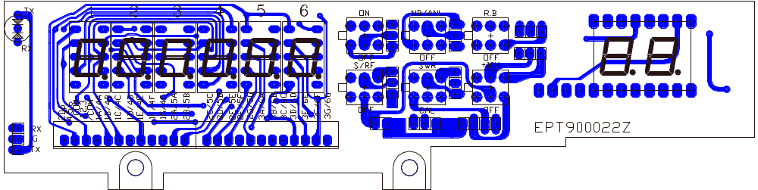

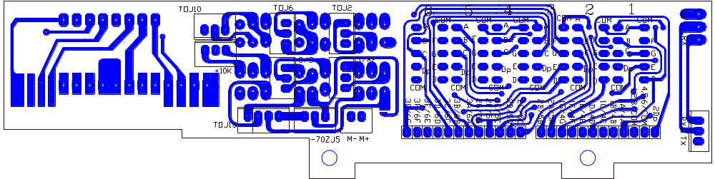

PART LIST:

RCI-6300F HP / RCI-6300F TB LED DISPLAY P.C.B

ITEM | REFERENCE NUMBER | RANGER PART NUMBER | DESCRIPTION
1 |  | EPT900022Z | LED DISPLAY P.C.B
2 | DISPLAY PCB | EX03N40003 | LED DISPLAY
3 | 1,2,3,4,5,6 | EX03N40476 | LED DISPLAY
4 | TX/RX | EX01N40004 | LED
5 | ON,NB/ANL,R.B,S/RF,  SWR,+10K | EWPS33033X | PUSH SW.
6 | DISPLAY PCB | EX07N48928 | PCB CONN/S 12PIN
7 | TOJ10,+10K,S/RF,  M-M+ | EX07N48223 | PCB CONN/S 2PIN
8 | TOJ2,TOJ6 | EX07N48350 | PCB CONN/S 3PIN
9 | RX/G/TX | EX07N48947 | PCB CONN/S 3PIN
10 | TOJ13 | EX07W48824 | PCB CONN/S 4PIN

REMARK:
TOP: COMPONENT SIDE (BLUE)
BOTTOM: COPPER SIDE (BLUE)

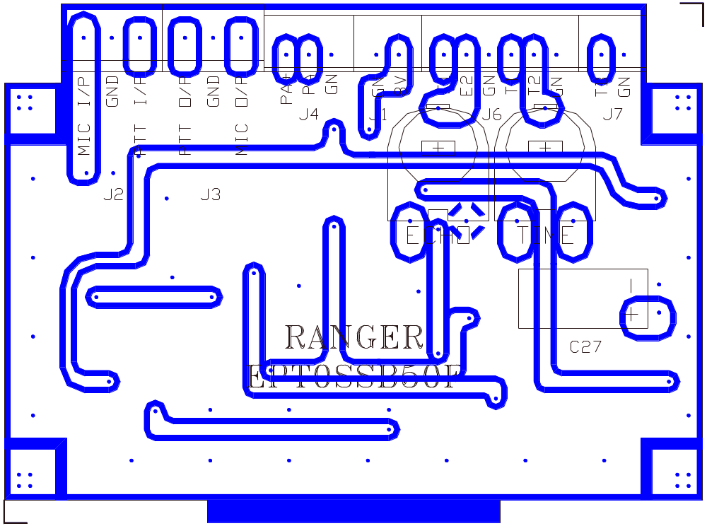

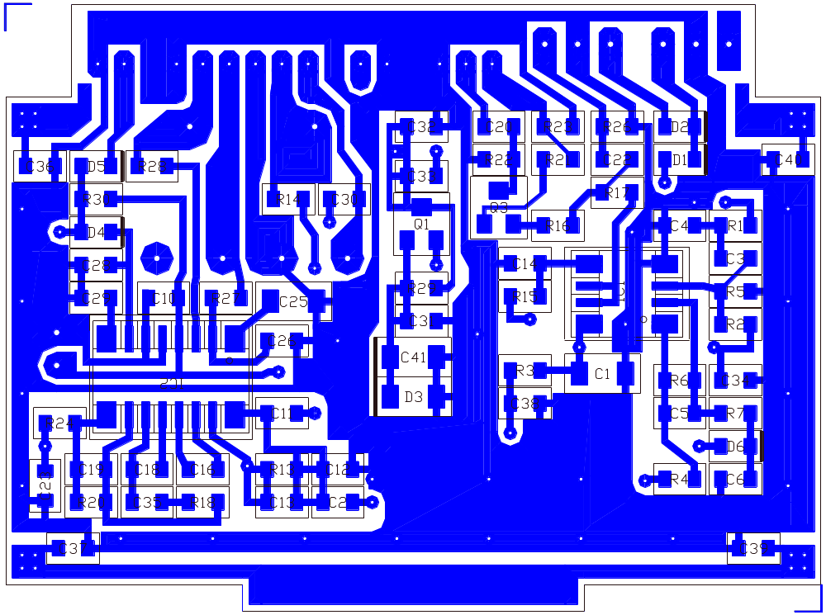

PART LIST:

RCI-6300F HP / RCI-6300F TB ECHO P.C.B (EB-99)

ITEM | REFERENCE NUMBER | RANGER PART NUMBER | DESCRIPTION
1 |  | EPT0SSB50F | ECHO P.C.B
2 | R3,R16 | RCY011014Z | 10 OHM 0.1W
3 | R28 | RCY014714Z | 470 OHM 0.1W
4 | R27 | RCY011024Z | 1K OHM 0.1W
5 | R7 | RCY012224Z | 2.2K OHM 0.1W
6 | R17,R29 | RCY014724Z | 4.7K OHM 0.1W
7 | R1,R23,R24,R30,R26 | RCY011034Z | 10K OHM 0.1W
8 | R18 | RCY012234Z | 22K OHM 0.1W
9 | R2,R5,R6,R13,R15,R22 | RCY013334Z | 33K OHM 0.1W
10 | R14,R20,R4 | RCY014734Z | 47K OHM 0.1W
11 | R21 | RCY011044Z | 100K OHM 0.1W
12 | C26 | CK1331AB5A | 330PF 50WV
13 | C5 | CK1561AB5A | 560PF 50WV
14 | C12,C14 | CK1102AB7L | 0.001uF 50WV
15 | C4,C11,C23,C34 | CK2103AB7R | 0.01uf 25WV
16 | C2,C3,C10,C16,C28,C29,C30,C32,C33,C36,C37,  C38,C39,C40,C18,C35 | CK2104AB7R | 0.1Uf 25WV
17 | C6,C31,C20,C22 | CK510AB7R | 1uF 16WV
18 | C13 | CK1152AB7R | 0.0015uF 50WV
19 | C19 | CK1472AB6U | .0047uF 50WV
20 | C25 | CK5105ZZ7R | 1uF 16WV
21 | C1 | CK5225AA7R | 2.2uF 16WV
22 | IC1 | YNJR04558M | IC NJM4558M 8PIN
23 | IC2 | YNES56033S | IC ES56033S 16PIN
24 | Q1,Q3 | TY2SC2712G | TR 2SC2712GR
25 | D1,D2,D4,D5,D6 | EDSS00355Y | DIODE 1SS355
26 | D3 | EDZD05569Y | ZENER DIODE 5.6V
27 | C27 | CE0164767Z | 47uF 16WV
28 | J3 | EX07N41216 | PCB CONN/S 3PIN
29 | J2 | EX07N41227 | PCB CONN/S 3PIN
30 | J1 | EX07N48223 | PCB CONN/S 2PIN
31 | J6 | EX07N48331 | PCB CONN/S 6PIN

REMARK:
TOP: COMPONENT SIDE (WHITE)
BOTTOM: COPPER SIDE (BLUE)

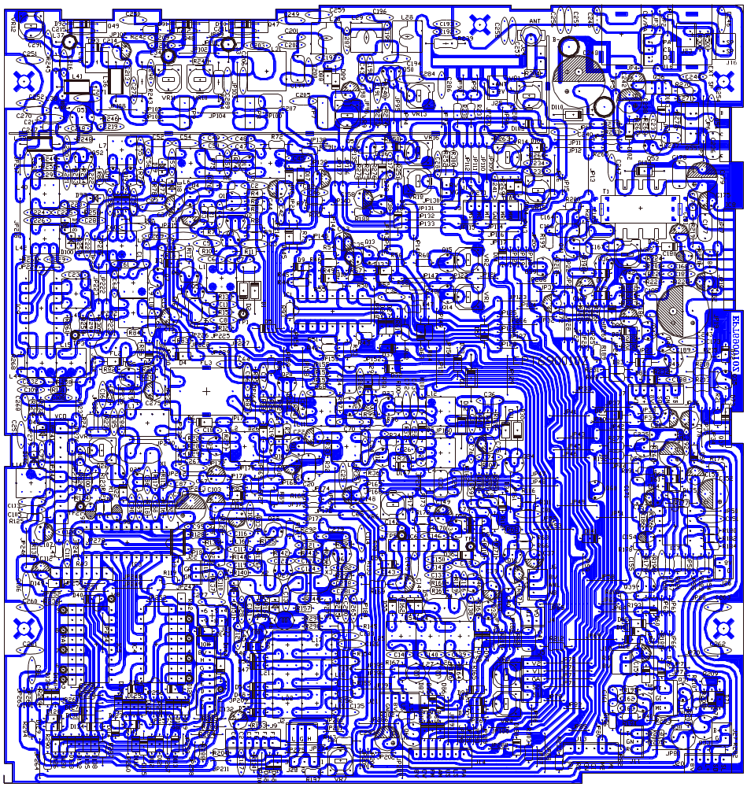

RCI-6300F HP / RCI-6300F TB MAIN PCB.

REMARK:
COPPER SIDE (WHITE)

PART LIST
RCI-6300F HP MAIN PCB

REFERENCE  NUMBER | RANGER  PART NO. | DESCRIPTION
 | EPT690010Z | MAIN P.C.B
R246 | RCP164794Z | 4.7 Ω 1/16W
R267 | RCP161504Z | 15 Ω 1/16W
R241,242 | RCP162204Z | 22 Ω 1/16W
R133,213,253,282,  VR10,VR11 | RCP164704Z | 47 Ω 1/16W
R130,215,220 | RCP165604Z | 56 Ω 1/16W
R11 | RCP166804Z | 68 Ω 1/16W
R3,5,8,30,33,76,81, 259,260,263,JP237 | RCP161014Z | 100 Ω 1/16W
R32,249 | RCP161514Z | 150 Ω 1/16W
R23 | RCP161814Z | 180 Ω 1/16W
R140,163,177 | RCP162214Z | 220 Ω 1/16W
R31 | RCP162714Z | 270 Ω 1/16W
R6,10,16,24,248,254,300 | RCP163314Z | 330 Ω 1/16W
R141,188,268,293 | RCP164714Z | 470 Ω 1/16W
R258,266 | RCP165614Z | 560 Ω 1/16W
R4,50,209 | RCP166814Z | 680 Ω 1/16W
R74 | RCP168214Z | 820 Ω 1/16W
R36,62,64,67,72,115,  116,118,123,136-138,  143,144,160,164,179,  186,189,205,214,232,261,291,292,295,303,  206,237 | RCP161024Z | 1KΩ 1/16W
R192 | RCP161224Z | 1.2KΩ 1/16W
R132,207,233,247,255,273,79,80 | RCP161524Z | 1.5KΩ 1/16W
R226 | RCP161824Z | 1.8KΩ 1/16W
R20,27,71,73,75,134,  162,122,283 | RCP162224Z | 2.2KΩ 1/16W
R9,25,28 | RCP162724Z | 2.7KΩ 1/16W
R18,22,58,66,128,129,191,219,274,277 | RCP163324Z | 3.3KΩ 1/16W
R52,57 | RCP163924Z | 3.9KΩ 1/16W
R26,35,131,165,190,  195,196 | RCP164724Z | 4.7KΩ 1/16W
R264,265 | RCP165624Z | 5.6KΩ 1/16W
R14,40,41,82,127,148,297 | RCP166824Z | 6.8KΩ 1/16W
R275 | RCP168224Z | 8.2KΩ 1/16W
R1,13,17,37,38,65,  142,145,159,161,168,175,181,202,216,227-231,272,276,294,296,262,68 | RCP161034Z | 10KΩ 1/16W
R178 | RCP161234Z | 12KΩ 1/16W
R180 | RCP161534Z | 15KΩ 1/16W
R187,208 | RCP162234Z | 22KΩ 1/16W
R121 | RCP162734Z | 27KΩ 1/16W
R2 | RCP163334Z | 33KΩ 1/16W
R46 | RCP163934Z | 39KΩ 1/16W
R7,29,61,63,126,185,  218,234,235,236,224,  222. | RCP164734Z | 47KΩ 1/16W
R21,85,105,107 | RCP166834Z | 68KΩ 1/16W
R45 | RCP168234Z | 82KΩ 1/16W
R12,42-44,51,53,77,  78,104,108,112,182,  184,225,256,257,278,  221 | RCP161044Z | 100KΩ 1/16W
R47,59,117,135,139,  194 | RCP162244Z | 220KΩ 1/16W
R49,55,176 | RCP162744Z | 270KΩ 1/16W
R15,34,111,183 | RCP164744Z | 470KΩ 1/16W
R48 | RCP168244Z | 820KΩ 1/16W
R106 | RCP161054Z | 1MΩ 1/16W
R193 | RCP161554Z | 1.5MΩ 1/16W
R124 | RCP161064Z | 10MΩ 1/16W
JP264 | RCP142204Z | 22 Ω 1/4W
R243,244 | RCP121514Z | 150 Ω 1/2W
R239 | RCP121034Z | 10KΩ 1/2W
C1,49,108,119,122,  279,147 | CC0501004L | 10PF 50WV
C224 | CC0501504L | 15PF 50WV
C195 | CC0501804L | 18PF 50WV
C24,287 | CC0503304L | 33PF 50WV
C8 | CC0508204L | 82PF 50WV
C4,53 | CC0501015L | 100PF 50WV
C137 | CC0501515L | 150PF 50WV
C56,222 | CC0501815L | 180PF 50WV
C28 | CC0502215L | 220PF 50WV
C31,136 | CC0502715L | 270PF 50WV
C11,14 | CC0503315L | 330PF 50WV
C23 | CC0505615L | 560PF 50WV
C197 | CC0500101A | 1PF 50WV
C225 | CC0500201A | 2PF 50WV
C286 | CC0500301A | 3PF 50WV
C61,62,90,226,218 | CC0500501A | 5PF 50WV
C89 | CC0501504A | 15PF 50WV
C43 | CC0501804A | 18PF 50WV
C84 | CC0502704A | 17PF 50WV
C202 | CC0504704A | 47PF 50WV
C88,116,117 | CC0506804A | 68PF 50WV
C192 | CC0508204A | 82PF 50WV
C194 | CC0501515A | 150PF 50WV
C196,295 | CC0501815A | 180PF 50WV
C139 | CC0503904D | 39PF 50WV
C281 | CC0501015G | 100PF 50WV
C282 | CC0501815G | 180PF 50WV
C124 | CC0506804G | 68PF 50WV
C123 | CC0501215G | 120PF 50WV
C220 | CC0502215G | 220PF 50WV
C86 | CC0502715G | 270PF 50WV
C85,201,203 | CC0503915G | 390PF 50WV
C209,210 | CC0504715G | 470PF 50WV
C199 | CD3005614Z | 560P 300WV
C7,47,50,74,95,99,  100,110,118,120,174,183,244,246,245, | CC0501027L | 0.001UF 50WV
C161 | CC0501537L | 0.015UF 50WV
C81,83,111,113,126,  173,193,206,207,211-213,228,234,236,249,250,256,259,268,272,280,288,292,296  (COPPER SIDE),C270,  C177,R302 | CC0501047L | 0.1UF 50WV
C5,18,20,48,65,87,92,96,102,105,106,151,160,233,251-253,257,  258,260-263,240 | CC0504737L | 0.047uF 50WV
C32,42,45,46,221,162,163 | CC0504727L | 0.0047UF 50WV
C155 | CC0502237L | 0.022UF 50WV
C200 | CC1001037L | 0.01UF 100WV
C2,3,6,9,15-17,19,  25,51,57,58,60,109,  114,121,138,188,189,205,216,217,219,223,229,230,232,247,254,255,265,267,269,271,277,278,285,184 | CC0501037L | 0.01UF 50WV
C154 | CT0162246Z | 0.22UF 16WV
C97 | CT0164746Z | T/C0.47UF 16WV
C98 | CT0162256Z | 2.2UF 16WV
C112 | CT0161056Z | 1UF 16WV
C40,178,171,235 | CM0501045Z | 0.1UF 50WV
C26,27,237 | CM0501025Z | 0.001UF 50WV
C29,78,185,41 | CM0501035Z | 0.01UF 50WV
C39 | CM0502235Z | 0.022UF 50WV
C176 | CM0504725Z | 0.0047UF 50WV
C34 | CM0504735Z | .047UF 50WV
C12,30,101 | CM0502225Z | .0022UF 50WV
C10 | CE0504747Z | 0.47UF 50WV
C67,75,153,157,170,  186,187,198 | CE0501057Z | 1UF 50WV
C159,214,148 | CE0502257Z | 2.2UF 50WV
C38,103,182 | CE0504757Z | 4.7UF 50WV
C13,21,22,44,82,115,158,275,276 | CE0251067Z | 10UF 25WV
C80,181 | CE0252267Z | 22UF 25WV
C37,175 | CE0254767Z | 47UF 25WV
C107,156,238,293 | CE0161077Z | 100UF 16WV
C152,179 | CE0163377Z | 330UF 16WV
C91 | CE0104777Z | 470UF 10WV
C243,248 | CE0251087Z | 1000UF 25WV
C35 | CEM254767Z | 47UF 25WV
FL1 | EFCFW455HT | C/FILTER 455HT
FL2 | EFCFE107MX | C/FILTER 10.7MX RED
X1 | EYCAB10240 | CRYSTAL 10.240MHZ
X2 | EYCAA15360 | CRYSTAL 15.360MHZ
X3 | EYBAA12660 | CRYSTAL 12.660MHZ
X4 | EYBAE10697 | CRYSTAL 10.6975MHZ
IC1 | ENJR00324D | NJM324D
IC3 | ENMC45106P | MC145106
IC4,5 | ENMC14008B | MC14008BCP
IC7 | ENJR04558D | NJM4558D
IC9 | ENSM06130Z | TDA6130
VCO | ENRG0IC090 | IC090 10PIN
Q8,17 | T2SC01674L | 2SC1674L
Q51 | T2SC02538Z | 2SC2538
Q52 | T2SC01906Z | 2SC1906
Q26,36 | TDTC0124ES | DTC124ES
Q24,43 | TDTC0114ES | DTC114S
Q30,33,62 | T2SA01282E | 2SA1282AE
Q1,2,9,10-12,25,27,  28,29,46,61 | T2SC01675L | 2SC1675
Q60 | TDTA0124ES | DTA124ES
Q3-5,7,14,16,31,35,  39,42,44,53,57,58,40 | T2SC00945P | 2SC945P
Q6,38 | T2SA00733P | 2SA733P
Q55 | T2SA01869Z | 2SA1869
Q18,19 | FM0J00310Z | F.E.T J310
D3,5,7-10,13,14,20-23,27,33,34,35,37,  40,53,60-65,69,75-82,84,85,88-91,97,  102,106,107,111-141,  143,144,147,149,150,JP191 | ED1N04148Z | DIODE 1N4148
D1,2,11,12,30,31 | ED1N00060P | 1N60P
D110 | ED1N04003Z | 1N4003
D109 | ED1N04007Z | 1N4007
D16,17 | EDSS00053Z | ISS53
D59,72 | EDMA00027W | MA27W-A
D71,145 | EDMA00027T | MA27T-A
D18,19,42,99,100,  146,148 | EDSV00251Z | SVC-251SPA
D70 | EDZD05519Z | 5.1V 0.5W
D73 | EDZD05759Z | 7.5V 0.5W
L2,3 | ECIFT12002 | I.FT
L6 | ECIFT12290 | I.F.T
L17,20 | ECIFT12012 | I.F.T
L23 | ECIFT12016 | I.F.T
L1 | ECIFT12252 | I.F.T
L44 | ECIFT12255 | I.F.T
L9,10 | ECIFT12256 | I.F.T
L15,43 | ECIFT12258 | I.F.T
L40 | ECIFT12262 | I.F.T
L14 | ECIFT12558 | I.F.T
L5 | ECIFT12253 | I.F.T
L7,42 | ECIFT12440 | I.F.T
L8 | ECIFT12492 | I.F.T
L4 | ECIFT12526 | I.F.T
L503,504 | ECCHK16000 | CHOKE COIL
T1 | ECCHK16004 | CHOKE COIL
L34,37,33 | ECCHK16070 | CHOKE COIL
L47 | ECCHK16176 | CHOKE COIL
L16 | ECCHK16246 | CHOKE COIL
L28 | ECSPG18003 | SPRING COIL
L30 | ECSPG18077 | SPRING COIL
L29 | ECSPG18075 | SPRING COIL
L31 | ECSPG18365 | SPRING COIL
L35 | ECSPG18001 | SPRING COIL
L38 | ECRFZ10048 | RF COIL
L13,39,41 | ECBAD18526 | BEAD COIL
VR16 | RE10200041 | S/F/R 1K
VR14,18 | RE50200042 | S/F/R 5K
VR1,5 | RE10300031 | S/F/R 10K
VR9 | RE10400043 | S/F/R 100K
VR4 | RE50400087 | S/F/R 500K
RA1 | RCS0870014 | R/ARRAY
RA2 | RCS0970015 | R/ARRAY
RA3 | RCS0670025 | R/ARRAY
C165-R223 | WL0007009Z | LEAD WIRE
C167-R223 | WL0207009Z | LEAD WIRE
J29 | WX01070703 | J/W 7x3x7
JP1-3,4,7,9,23,24-26  ,32,33,38,39,50,54-57,59,61,62,63,65,66,71,72,79,80,82,85,  86,87,93,100,105,106,114,115,118-122,124  -126,190,135,138-140  ,144,145,152,153,156,157,159,160,128,165,166,168,170,172,174,175,177-179,181,184  ,188,91,190 | WX01060605 | J/W 6x5x6
JP200-202,204,205,  209-211,212,214,217,  219,220,224,226,231-233,235,236,238,239,242,243,245,250,252,253,255-260,262,263,  265,271-273,276,278-  280,285,267x2,R245,  R305,R89,C142,C291,  D26,D46,D50,D95,D49-L46,TP8,C133 | WX01070705 | J/W 7x5x7
R19,119 | WX01070706 | J/W 7x6x7
D25 | WX01070708 | J/W 7x8x7
JP6,11,12,16-19,34-  37,40-49,51-53,58,60  ,67,70,88,96,101-104  ,107-109,116,117,127  ,129,133,136,137,143,147,148,151,161,167,169,176,131,132,111,130 | WX01060610 | J/W 6x10x6
JP215,218,222,223,  225,227,228,230,234,241,244,246-249,251,  254,261,266,277,286,287,240,IC6,C128-L45  ,L36 | WX01070710 | J/W 7x10x7
JP75-78,81,193 | WX01070712 | J/W 7x12x7
JP99 | WX01070713 | J/W 7x13x7
FL3 | WX01070715 | J/W 7x15x7
TP7-TP8,TP8-TP9 | WX01070718 | J/W 7x18x7
J7x2,10,17,22,Q41 | EX07N48223 | P/C/S 3P
J2,3,6,11,18 | EX07N48350 | P/C/S 3P
J21 | EX07N48490 | P/C/S 4P
J5,20 | EX07N48222 | P/C/S 5P
J13 | EX07N48331 | P/C/S 6P
J14 | EX07N48224 | P/C/S 7P
J1 | EX07N48543 | P/C/S 9P
J28 | EX07N48244 | P/C/S 3P
J12 | EX07N41227 | P/C/S 3P
J16 | EX07N41330 | P/C/S 2P
J4 | EX07N49140 | P/C/S 2P
J28 | EX07N48151 | P/C/H
TP2,3,5 | EX07N48612 | P/C/S 1PIN
EXT SP,CW/PA | EX06N41045 | EAR JACK
DC SOCKETx2 | CC0501037L | 0.01uF 50WV
IC8 | ENTA07222A | IC TA7222AP
Q54 | T2SB00754Y | TR 2SB754Y
Q49 | T2SC02166C | TR 2SC2166C
Q47,48 | T2SC02312C | TR 2SC2312C
Q37 | T2SA01869Z | TR 2SA1869
DC SOCKET | EDLT6A400Z | DIODE LT6A400

RCI-6300F HP MISC. PARTS

REFERENCE  NUMBER | RANGER  PART NO. | DESCRIPTION

- | MM7878041B | HEAT SINK
- | MT3001021X | SET CHASSIS
- | MT3600050X | DC SOCKET HOLDER
2SB754Y | XZZZ90020Z | INSULATING PLATE
Q47,48,49 | XZZZ90003Z | INSULATING PLATE
Q47,48,49 | XZZZ90358Z | INSULATING PLATE
IC8 | LZZZ61008Z | IC SHIELD B
DC(2) | JS053006MN | SET SCREW
Q37 | JS052006MN | SET SCREW
Q47,48,49 | JS052012MN | SET SCREW
IC8 | JS013006MV | SET SCREW
Q54 | JS052010MN | SET SCREW
HEAT SINK | JS013008TN | SET SCREW
ANT JACK(1),MIC JACK(1) | XZZZ90098Z | SOLDER PLATE
- | ES300835SQ | SPEAKER
- | PT9000060K | FRONT PANEL
- | PT9000020E | CH KNOB
- | PT9000040E | INNER KNOB
- | PT9000050E | OUTER KNOB
- | PT3600080A | SIGNAL METER HOLDER
- | PT9000070E | BAND KNOB
- | PT2100031C | COUNT WINDOW
- | PT2100041C | DISPLAY WINDOW
- | PT7001070C | PUSH KEY
- | MT9000010X | FRONT CHASSIS
- | MT3600040S | CHANNEL BRACKET
- | MT3600061X | TOP HOUSING
- | MT36000710 | BOTTOM HOUSING
- | MT3600030S | HANDLER
- | XZZZ90004Z | FOAM
- | XZZZ90005Z | FOAM
- | XZZZ90367A | SPONGE
- | GZZZ50000Z | CLAMP
- | XZZZ90098Z | SOLDER PLATE
- | XZZZ90021Z | FOAM
- | XZZZ90064Z | INSULATING PLATE
COUNTER | XZZZ90363Z | PVC STAND OFF
COUNTER | JS013016WH | SET SCREW
FRONT PANEL(4) | JS033008MN | SET SCREW
TONE(2),CH9(2),  WB/ANL(2) | JS052004MN | SET SCREW
SWR SW(2) | JS052605MN | SET SCREW
CH BKT(2),  CHASSIS(12) | JS053006MN | SET SCREW
SPK(4) | JS053008MN | SET SCREW
MAIN PCB(5) | JS053006TN | SET SCREW
SPK(4) | JN263035ZS | NUT WITH WASHER
- | HZZZ76005Z | SSEBRIH K 905

PART LIST
RCI-6300F TB MAIN PCB

REFERENCE  NUMBER | RANGER  PART NO. | DESCRIPTION
 | EPT690010Z | MAIN P.C.B
R246 | RCP164794Z | 4.7 Ω 1/16W
R267 | RCP161504Z | 15 Ω 1/16W
R241,VR10 | RCP162204Z | 22 Ω 1/16W
J3(2-4P) | RCP163304Z | 33 Ω 1/16W
R133,213,253,282 | RCP164704Z | 47 Ω 1/16W
R130,215,220,249 | RCP165604Z | 56 Ω 1/16W
R11 | RCP166804Z | 68 Ω 1/16W
R3,5,8,30,33,76,81, 259,260,263,JP237 | RCP161014Z | 100 Ω 1/16W
R32 | RCP161514Z | 150 Ω 1/16W
R23 | RCP161814Z | 180 Ω 1/16W
R140,163,177 | RCP162214Z | 220 Ω 1/16W
R31 | RCP162714Z | 270 Ω 1/16W
R6,10,16,24,248,254,300 | RCP163314Z | 330 Ω 1/16W
R141,188,268,293 | RCP164714Z | 470 Ω 1/16W
R258,266 | RCP165614Z | 560 Ω 1/16W
R4,50,209 | RCP166814Z | 680 Ω 1/16W
R74 | RCP168214Z | 820 Ω 1/16W
R36,62,64,67,72,115,  116,118,123,136-138,  143,144,160,164,179,  186,189,205,214,232,261,291,292,295,303,  206,L5 | RCP161024Z | 1KΩ 1/16W
R192 | RCP161224Z | 1.2KΩ 1/16W
R132,207,233,247,255,273,79,80 | RCP161524Z | 1.5KΩ 1/16W
R226 | RCP161824Z | 1.8KΩ 1/16W
L7 | RCP162024Z | 2KΩ 1/16W
R20,27,71,73,75,134,  162,122,283 | RCP162224Z | 2.2KΩ 1/16W
R9,25,28 | RCP162724Z | 2.7KΩ 1/16W
R18,22,58,66,128,129,191,219,274,277 | RCP163324Z | 3.3KΩ 1/16W
R52,57 | RCP163924Z | 3.9KΩ 1/16W
R26,35,131,165,190,  195,196 | RCP164724Z | 4.7KΩ 1/16W
R264,265 | RCP165624Z | 5.6KΩ 1/16W
R14,40,41,82,127,148,297,70 | RCP166824Z | 6.8KΩ 1/16W
R275 | RCP168224Z | 8.2KΩ 1/16W
R1,13,17,37,38,65,  142,145,159,161,168,175,181,202,216,227-231,272,276,294,296,262,68 | RCP161034Z | 10KΩ 1/16W
R178 | RCP161234Z | 12KΩ 1/16W
R180 | RCP161534Z | 15KΩ 1/16W
R187,208 | RCP162234Z | 22KΩ 1/16W
R121 | RCP162734Z | 27KΩ 1/16W
R2 | RCP163334Z | 33KΩ 1/16W
R46 | RCP163934Z | 39KΩ 1/16W
R7,29,61,63,126,185,  218,234,235,236,224,  222. | RCP164734Z | 47KΩ 1/16W
R21,85,105,107 | RCP166834Z | 68KΩ 1/16W
R45 | RCP168234Z | 82KΩ 1/16W
R12,42-4,51,53,77,78
,104,108,112,182,184,225,256,257,278,221
R47,59,117,135,139,  194 | RCP162244Z | 220KΩ 1/16W
R49,55,176 | RCP162744Z | 270KΩ 1/16W
R15,34,111,183 | RCP164744Z | 470KΩ 1/16W
R48 | RCP168244Z | 820KΩ 1/16W
R106 | RCP161054Z | 1MΩ 1/16W
R193 | RCP161554Z | 1.5MΩ 1/16W
R124 | RCP161064Z | 10MΩ 1/16W
JP264 | RCP142204Z | 22 Ω 1/4W
R244 | RCP121514Z | 150 Ω 1/2W
R239 | RCP121034Z | 10KΩ 1/2W
C1,49,108,119,122,  279,147 | CC0501004L | 10PF 50WV
C224 | CC0501504L | 15PF 50WV
C195 | CC0501804L | 18PF 50WV
C24,287 | CC0503304L | 33PF 50WV
C8 | CC0508204L | 82PF 50WV
C4,53 | CC0501015L | 100PF 50WV
C137 | CC0501515L | 150PF 50WV
C56,222 | CC0501815L | 180PF 50WV
C28 | CC0502215L | 220PF 50WV
C31,136 | CC0502715L | 270PF 50WV
C11,14 | CC0503315L | 330PF 50WV
C23 | CC0505615L | 560PF 50WV
C197 | CC0500101A | 1PF 50WV
C225,52 | CC0500201A | 2PF 50WV
C61,62,90,226,218 | CC0500501A | 5PF 50WV
C89 | CC0501504A | 15PF 50WV
C43 | CC0501804A | 18PF 50WV
C84 | CC0502704A | 17PF 50WV
C202 | CC0504704A | 47PF 50WV
C88,116,117 | CC0506804A | 68PF 50WV
C192,8 | CC0508204A | 82PF 50WV
C194 | CC0501515A | 150PF 50WV
C196,295 | CC0501815A | 180PF 50WV
C139 | CC0503904D | 39PF 50WV
C281 | CC0501015G | 100PF 50WV
C282 | CC0501815G | 180PF 50WV
C124 | CC0506804G | 68PF 50WV
C123 | CC0501215G | 120PF 50WV
C220 | CC0502215G | 220PF 50WV
C86 | CC0502715G | 270PF 50WV
C85,201,203 | CC0503915G | 390PF 50WV
C209,210 | CC0504715G | 470PF 50WV
C199 | CD3005614Z | 560P 300WV
C7,47,50,74,95,99,  100,110,118,120,174,183,244,246,245 | CC0501027L | 0.001UF 50WV
C161 | CC0501537L | 0.015UF 50WV
C81,83,111,113,126,  173,193,206,207,211,213,228,234,236,249,250,256,259,268,272,280,288,292,296  (COPPER SIDE),C270,  C177,R302 | CC0501047L | 0.1UF 50WV
C5,18,20,48,65,87,92,96,102,105,106,151,160,233,251-253,257,  258,260-263,240 | CC0504737L | 0.047uF 50WV
C32,42,45,46,221,162,163 | CC0504727L | 0.0047UF 50WV
C155 | CC0502237L | 0.022UF 50WV
C200 | CC1001037L | 0.01UF 100WV
C2,3,6,9,15-17,19,25  ,51,57,58,60,109,114,121,138,188,189,205,216,217,219,223,229,230,232,247,254,255,265,267,269,271,277,278,285,184 | CC0501037L | 0.01UF 50WV
C154 | CT0162246Z | 0.22UF 16WV
C97 | CT0164746Z | 0.47UF 16WV
C98 | CT0162256Z | 2.2UF 16WV
C112 | CT0161056Z | 1UF 16WV
C40,178,171,235 | CM0501045Z | 0.1UF 50WV
C26,27,237,39 | CM0501025Z | 0.001UF 50WV
C29,185 | CM0501035Z | 0.01UF 50WV
C41 | CM0502235Z | 0.022UF 50WV
C176 | CM0504725Z | 0.0047UF 50WV
C34 | CM0504735Z | .047UF 50WV
C12,30,101 | CM0502225Z | .0022UF 50WV
C78 | CM0502245Z | .22UF 50WV
C10 | CE0504747Z | 0.47UF 50WV
C67,75,153,157,170,  186,187,198 | CE0501057Z | 1UF 50WV
C159,214,148 | CE0502257Z | 2.2UF 50WV
C38,103,182 | CE0504757Z | 4.7UF 50WV
C13,21,22,44,82,115,158,275,276 | CE0251067Z | 10UF 25WV
C80,181 | CE0252267Z | 22UF 25WV
C37,175 | CE0254767Z | 47UF 25WV
C107,156,238,293 | CE0161077Z | 100UF 16WV
C152,179 | CE0163377Z | 330UF 16WV
C91 | CE0104777Z | 470UF 10WV
C243,248 | CE0251087Z | 1000UF 25WV
C35 | CEM254767Z | 47UF 25WV
FL1 | EFCFW455HT | C/FILTER 455HT
FL2 | EFCFE107MX | C/FILTER 10.7MX RED
X1 | EYCAB10240 | CRYSTAL 10.240MHZ
X2 | EYCAA15360 | CRYSTAL 15.360MHZ
X3 | EYBAA12660 | CRYSTAL 12.660MHZ
X4 | EYBAE10697 | CRYSTAL 10.6975MHZ
IC1 | ENJR00324D | I.C.NJM324D
IC3 | ENMC45106P | MC145106
IC4,5 | ENMC14008B | MC14008BCP
IC7 | ENJR04558D | NJM4558D
IC9 | ENSM06130Z | TDA6130
VCO | ENRG0IC090 | IC090 10PIN
Q8,17 | T2SC01674L | 2SC1674L
Q51 | T2SC02538Z | 2SC2538
Q52 | T2SC01906Z | 2SC1906
Q26,36 | TDTC0124ES | DTC124ES
Q24,43 | TDTC0114ES | DTC114S
Q30,33,62 | T2SA01282E | 2SA1282AE
Q1,2,9,10-12,25,27,  28,29,46,61 | T2SC01675L | 2SC1675
Q60 | TDTA0124ES | DTA124ES
Q3-5,7,14,16,31,35,  39,42,44,53,57,58,40 | T2SC00945P | 2SC945P
Q6,38 | T2SA00733P | 2SA733P
Q55 | T2SA01869Z | 2SA1869
Q18,19 | FM0J00310Z | F.E.T J310
D3,5,7-10,13,14,20-23,27,33,34,35,37,40,53,60-65,69,75-82,  84,85,88-90,97,102,  106,107,111-141,143,  144,147,149,150,  JP191 | ED1N04148Z | DIODE 1N4148
D1,2,11,12,30,31 | ED1N00060P | 1N60P
D110 | ED1N04003Z | 1N4003
D109 | ED1N04007Z | 1N4007
D16,17 | EDSS00053Z | ISS53
D59,72 | EDMA00027W | MA27W-A
D71,145 | EDMA00027T | MA27T-A
D18,19,42,99,100,146,148 | EDSV00251Z | SVC-251SPA
D70 | EDZD05519Z | 5.1V 0.5W
D73 | EDZD05759Z | 7.5V 0.5W
L2,3 | ECIFT12002 | I.FT
L6 | ECIFT12290 | I.F.T
L17,20 | ECIFT12012 | I.F.T
L23 | ECIFT12016 | I.F.T
L1 | ECIFT12252 | I.F.T
L44 | ECIFT12255 | I.F.T
L9,10 | ECIFT12256 | I.F.T
L15,43 | ECIFT12258 | I.F.T
L40 | ECIFT12262 | I.F.T
L14 | ECIFT12558 | I.F.T
L5 | ECIFT12253 | I.F.T
L7,42 | ECIFT12440 | I.F.T
L8 | ECIFT12492 | I.F.T
L4 | ECIFT12526 | I.F.T
L503,504 | ECCHK16000 | CHOKE COIL
T1 | ECCHK16004 | CHOKE COIL
L37,33 | ECCHK16070 | CHOKE COIL
L47 | ECCHK16176 | CHOKE COIL
L16 | ECCHK16246 | CHOKE COIL
L28 | ECSPG18003 | SPRING COIL
L30 | ECSPG18077 | SPRING COIL
L29 | ECSPG18075 | SPRING COIL
L31 | ECSPG18365 | SPRING COIL
L35 | ECSPG18001 | SPRING COIL
L38 | ECRFZ10048 | RF COIL
L13,39,41 | ECBAD18526 | BEAD COIL
VR16,18 | RE10200041 | S/F/R 1K
VR14 | RE50200042 | S/F/R 5K
VR1,5 | RE10300031 | S/F/R 10K
VR9 | RE10400043 | S/F/R 100K
VR4 | RE50400087 | S/F/R 500K
RA2 | RCS0870014 | R/ARRAY
RA1 | RCS0970015 | R/ARRAY
RA3 | RCS0670025 | R/ARRAY
R201-R223 | WL0007009Z | LEAD WIRE
R223-R198 | WL0207009Z | LEAD WIRE
JP1-3,4,7,9,23,24-26  ,32,33,38,39,50,54-57,59,61,62,63,65,66,71,72,79,80,82,85,  86,87,93,100,105,106,114,115,118-122,124  -126,190,135,138-140  ,144,145,152,153,156,157,159,160,128,165,166,168,170,172,174,175,177-179,181,184  ,188,125 | WX01060605 | J/W 6x5x6
JP200-202,204,205,  209,211,212,214,217,219,220,224,226,231-233,235,236,238,239,242,243,245,250,252,253,255-260,262,263,  265,271-273,276,278-  280,285,267x2,R119,  R305,R89,R19,C142,  C291,C128,C129,D26,  D46,D50,D49-L46,TP8,  C133,D95 | WX01070705 | J/W 7x5x7
R19,119 | WX01070706 | J/W 7x6x7
D25 | WX01070708 | J/W 7x8x7
JP6,11,12,16-19,34-  37,40-49,51-3,58,60,  67,70,88,96,101-104,  107-109,116,117,127,  129,133,136,137,143,147,148,151,161,167,169,176,131,132,240 | WX01060610 | J/W 6x10x6
JP215,218,222,223,  225,227,228,230,234,241,244,246-249,251,  254,261,266,277,286,287,IC6,L36 | WX01070710 | J/W 7x10x7
JP75-78,81 | WX01070712 | J/W 7x12x7
JP99 | WX01070713 | J/W 7x13x7
FL3 | WX01070715 | J/W 7x15x7
TP7-TP8,TP8-TP9 | WX01070718 | J/W 7x18x7
J7x2,10,17,22,Q41 | EX07N48223 | P/C/S 3P
J2,3,6,11,18 | EX07N48350 | P/C/S 3P
J21 | EX07N48490 | P/C/S 4P
J5,20 | EX07N48222 | P/C/S 5P
J13,7 | EX07N48331 | P/C/S 6P
J14 | EX07N48224 | P/C/S 7P
J1 | EX07N48543 | P/C/S 9P
J28 | EX07N48244 | P/C/S 3P
J12 | EX07N41227 | P/C/S 3P
J16 | EX07N41330 | P/C/S 2P
J28 | EX07N48151 | P/C/H
TP2,3,5 | EX07N48612 | P/C/S 1PIN
IC8 | ENTA07222A | IC TA7222AP
Q54 | T2SB00754Y | TR 2SB754Y
Q49 | T2SC02166C | TR 2SC2166C
Q47 | T2SC01969C | TR 2SC1969C
Q37 | T2SA01869Z | TR 2SA1869

RCI-6300F TB MISC. PARTS

REFERENCE  NUMBER | RANGER  PART NO. | DESCRIPTION

- | PT9000060K | FRONT PANEL
- | PT9000020E | CH KNOB
- | PT9000070E | BAND KNOB
- | PT9000040E | INNER KNOB
- | PT9000050E | OUTER KNOB
- | PT2100041C | DISPLAY WINDOW
- | PT3600080A | SIGNAL METER HOLDER
- | PT2100031C | COUNT WINDOW
- | PT7001070C | PUSH KEY
- | MT9000010X | FRONT CHASSIS
- | MT3600040S | CHANNEL BRACKET
- | MT3600061X | TOP HOUSING
- | MT3600071N | BOTTOM HOUSING
- | MT3600030S | HANDLER
- | XZZZ90004Z | FOAM
- | GZZZ50000Z | CLAMP
- | LZZZ60001Z | SHIELD CLOTH
- | XZZZ90098Z | SOLDER PLATE
- | XZZZ90021Z | FOAM
- | XZZZ90064Z | INSULATING PLATE
- | BA0112010P | MIC PLATE
COUNTER | XZZZ90363Z | PVC STAND OFF
COUNTER | JS013016WH | SET SCREW
FRONT PANEL(4) | JS033008MN | SET SCREW
CH BKT(2),  CHASSIS(12) | JS053006MN | SET SCREW
SPK(4) | JS053008MN | SET SCREW
MAIN PCB(5) | JS053006TN | SET SCREW
SPK(4) | JN263035ZS | NUT
- | XZZZ90008Z | MIC STOPPER
- | XZZZ90007Z | MOUNTING SCREW
- | JS015010WH | SET SCREW
- | JS013509TH | SET SCREW
- | JW315510CN | OUT-TOOTH WASHER
- | XZZZ90188Z | FIBER WASHER
- | HZZZ76005Z | SSSEBRIH K 905
- | MT3600200X | SET CHASSIS
2SB754Y | XZZZ90020Z | INSULATING PLATE
Q47,49 | XZZZ90003Z | INSULATING PLATE
Q47,49 | XZZZ90358Z | INSULATING PLATE
IC8 | LZZZ61008Z | IC SHIELD B
Q37 | JS052006MN | SET SCREW
Q47,49 | JS052012MN | SET SCREW
IC8 | JS013006MV | SET SCREW
- | JS052010MN | SET SCREW
Q47,49 | JN242012ZS | NUT

